

National Forest Reference Emission Levels (FRELs) for the Federal Republic of Nigeria:

**Federal Republic of Nigeria**

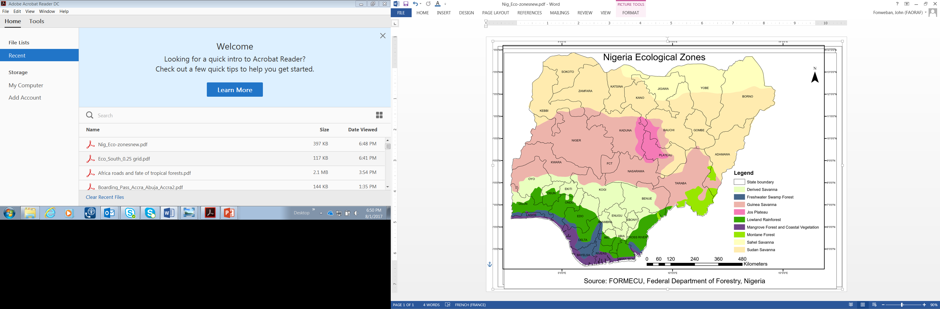

Federal Department of Forestry

Federal Ministry of Environment

Federal Republic of Nigeria

December 2018

**CONTACT INFORMATION**

National Coordinator, Nigeria REDD+ Programme

Federal Department of Forestry, Federal Ministry of Environment

Plot 393/394, Augustus Aikhomu way, Utako District, Abuja, Nigeria.

E-mail: [Nigeria_redd@yahoo.com](mailto:Nigeria_redd@yahoo.com). Or. [Mema20ng@yahoo.com](mailto:Mema20ng@yahoo.com)

Phone: +234-8033486909

**Table of Contents**

**List of Figures** 6

**List of Tables** 6

**List of Acronyms** 8

1. Introduction 9

2. FREL development process 9

3. Scale of FREL: Area covered 9

3.1 Geographical location, relief, climate, soils and Vegetation of Nigeria 10

3.2 Vegetation of Nigeria 13

3.2.1 Mangrove Forest and Coastal Vegetation Ecological Zone 14

3.2.2 Freshwater Swamp Forest Ecological Zone 14

3.2.3 Lowland Rain Forest Ecological Zone 14

3.2.4 Derived Savanna Ecological Zone 15

3.2.5 Guinea Savanna Ecological Zone 15

3.2.6 Sudan Savanna Ecological Zone 16

3.2.7 Jos Plateau Ecological Zone 16

3.2.8 Montane Region Ecological Zone 17

3.2.9 Sahel Savanna Ecological Zone 18

4. Scope: Activities, Pools and gases included 18

4.1 Activities included 18

4.2 Pools included 19

4.2.1 Omission of litter 19

4.2.2 Omission of soil organic carbon 20

4.3 Gases included 21

5. Forest Definition 21

6. Estimation of Historical Emissions 22

6.1 Activity Data 23

6.1.1 Description of Land use land use/land cover classification scheme for Nigeria 23

6.1.2 Production of Land use/Land cover Maps, change detection and Accuracy Assessment 26

6.1.3 Global Trends and Change Detection Analysis 28

6.1.4 Accuracy Assessment: 42

6.2 Emission factor estimation 46

6.2.1 Sampling design for Nigeria Forest Carbon Inventory 46

6.2.2 Cluster Design and Characteristics 47

6.2.3 Sample Plot Design: Mangroves & FWS 48

6.2.4 Data Collection: Above Ground Biomass 49

6.2.5 Data Analysis 52

***Estimation of Carbon content*** 55

7. Transparent, complete, consistent and accurate information 56

7.1 Transparent information 56

7.2 Complete information 56

7.3 Consistent information 56

7.4 Accurate information 57

7.4.1 Accuracy of the estimated activity data 57

7.4.2 Uncertainty of the estimated emission factor 57

8. FREL/FRL Construction 58

8.1 Reference Period 58

8.2 Average Method 58

9. Areas for future improvements 58

10. References 60

11. Appendices (separate document) 62

**List of Figures**

Figure 1: Geographical Location of Nigeria in Africa 11

Figure 2: Soil map of Nigeria 12

Figure 3: Ecological zones of Nigeria 13

Figure 4: Potential areas of peatlands in Nigeria (Source : https://www.cifor.org/global-wetlands/). 21

Figure 5: Nigeria Land cover 1995 (Source: FORMECU) 24

Figure 6. Flow chart for the land use/land cover map production and Accuracy Assessment 27

Figure 7. Land use/Land cover map for Nigeria (2006). 29

Figure 8. Land use/Land cover map for Nigeria (2016). 30

Figure 9. Annual land use/land cover changes (ha/yr.) 31

Figure 10. Flux diagram for the main transitions between land use types for the period 2006-2016. 35

Figure 11. Country division by major ecological zones. 36

Figure 12. Trends in land use/land cover changes for Nigeria, and by major zones in Nigeria (blue arrows show removals while red arrows indicate emissions). 37

Figure 13. Flux diagram for the main transitions between land use types for the Sudan and Sahel Savanna for the period 2006-2016. 38

Figure 14. Flux diagram for the main transitions between land use types for the Guinea and Derived Savanna for the period 2006-2016. 39

Figure 15. Flux diagram for the main transitions between land use types for the Lowland Rainforest for the period 2006-2016. 40

Figure 16. Flux diagram for the main transitions between land use types for the Mangrove and Freshwater swamps for the period 2006-2016. 41

Figure 17. National Forest cover change map (2006-2016) from Hansen Map 43

Figure 18. Estimated forest loss (deforestation) between 2006-2016 by ecological zones. 45

Figure 19. Estimated Forest loss, Stable Forest and Stable Non Forest within ecological zones. 46

Figure 20. Cluster design used for the inventory 47

Figure 21. Sketch diagram of sample Transect sampling design for Mangroves and Fresh Water Swamp Forest. 48

Figure 22. Spatial Distribution of Sample Clusters in different Ecological Zones. 49

**List of Tables**

Table 1. Land use/land cover areas and annual changes 31

Table 2: Transition Matrix for land use/land cover for 200-2016. 33

Table 3: Percentage changes for land use/land cover for 2006-2016 for Nigeria. 34

Table 4. Error matrix for the interpreted samples. 44

Table 5. Results of Accuracy Assessment and Stratified Area Estimation for Forest Classes for one interpreter. 44

Table 6. Number of Clusters enumerated in different ecological zones in Nigeria. 48

Table 7. Total live and Dead Biomass and Carbon Stocks for different ecological zones in Nigeria. 56

Table 8. Uncertainty estimates (95% confidence intervals) for total live and deadwood carbon stocks by ecological zones 57

Table 9. Summary computations for Emissions 58

**List of Appendices**

**List of Acronyms**

|  |  |
| --- | --- |
| AD | Activity Data |
| DCC | Department of Climate Change |
| EFs | Emission Factors |
| FAO | Food and Agriculture Organisation of the United Nations |
| FME | Federal Ministry of Environment |
| FORMECU | Forestry Monitoring and Evaluation Coordinating Unit |
| FRA | Forest Resources Assessment |
| FRELs/FRLs | Forest Reference Emission Levels/ Forest Reference Levels |
| FRIN | Forestry Research Institute of Nigeria |
| GHG-I | Greenhouse gas Inventory |
| IPCC | Intergovernmental Panel on Climate Change |
| LULUCF | Landuse, Landuse Change and Forestry |
| MCCF | Ministry of Climate Change and Forestry |
| MRV | Measurement, Reporting and Verification |
| NAGIS | Nasarawa State Geographic Information Services |
| NASRDA | Nigerian Airspace Research and Development Agency |
| NESREA | National Environmental Standards & Regulations Enforcement Agency | |
| NFI | National Forest Inventory |
| NFMS | National Forest Monitoring System |
| SLMS | Satellite Land Monitoring System |
| UNFCCC | United Nations Convention on Climate Change |

# Introduction

The Federal Republic of Nigeria welcomes the invitation to submit a Forest Reference Emission Levels (FREL) on a voluntary basis as expressed in Decision 12/CP.17, paragraph 13. This FREL submission is in the context of results-based payments for the implementation of reducing emissions from deforestation and forest degradation, and the role of conservation, sustainable management of forests and enhancement of forest carbon stocks (REDD+) under the United Nations Framework Convention on Climate Change (UNFCCC).

The government has followed the guidance provided by the UNFCCC through the decisions taken at the Conference of the Parties (CP), notably the modalities for forest reference emission levels and forest reference levels in Decision 12/CP.17 and the guidelines for submission of information on reference levels in the Annex of Decision 12/CP.17. This submission does not prejudge or modify any of Nigeria’s Nationally Determined Contributions (NDCs) or Nationally Appropriate Mitigation Actions (NAMAs) pursuant to the Bali Action Plan.

The Government intends to take a step-wise approach to its national FREL development as stated in Decision 12/CP.17, paragraph 10. As such, the current FRL reflects the best available information at the time of submission at national level. The scope and methodologies applied can be modified whenever improved data becomes available; and taking into account the previously submitted sub-national FREL. The historical period considered, and/or the construction approach could also be revised.

# FREL development process

The construction of the FREL in Nigeria began with the development of a sub-national FREL for Cross River State which was submitted to the UNFCCC for the technical assessment in 2018. The present national FREL is a follow up to the sub-national FREL, which up-scales it to national level. The entire FREL process was also subjected to a wider stakeholder consultation and review to ensure that it reflects the expectations of all stakeholders, and to also consider technical inputs from this broader group.

# Scale of FREL: Area covered

Nigeria’s REDD+ Programme envisioned a two-track approach to achieve REDD+ readiness, based on: (i) the development of institutional and technical capacities at Federal level, and (ii) consolidating four key UNFCCC requirements for REDD+ Readiness (Warsaw Framework for REDD+ elements) on a pilot basis in Cross River State. The present FREL is national and draws from the sub-national FREL that Nigeria submitted to UNFCCC in 2018.

## Geographical location, relief, climate, soils and Vegetation of Nigeria

The Federal Republic of Nigeria (henceforth referred to as Nigeria), is located on the west coast of Africa between latitudes 3°15’ to 13°30’ N and longitudes 2°59’ to 15°00’ E **(Figure 1**). It is bordered by Benin in the west, Niger in the north, Chad and Cameroon in the east, and the Gulf of Guinea in the Atlantic Ocean to the south. Nigeria is the 4th largest country in Africa with a land area of 923,768km2 of which 910768 km2 is land and 13,000 km2 is water (Nigeria, 2017[1]); and the most populated country in Africa, with an estimated population of over 182 million by late 2016 (cf. Vanguard, 2016; Nigeria, NPC, 2017).

|  |
| --- |
|  |

Nigeria is located mainly within the lowland humid tropics, characterized by high temperatures of up to 32oC in the coastal south and up to 41oC in the north. The climate varies from very wet typical in coastal areas with annual rainfall greater than 3500mm to dry in the Sahel region in the northwest and north-eastern parts, with annual rainfall below 600mm.

Nigeria has two main relief regions: the high plateaux ranging between 300 and more than 900m above sea level, and the lowlands, which are generally less than 300 m (Jeje and Adesina, 1995).

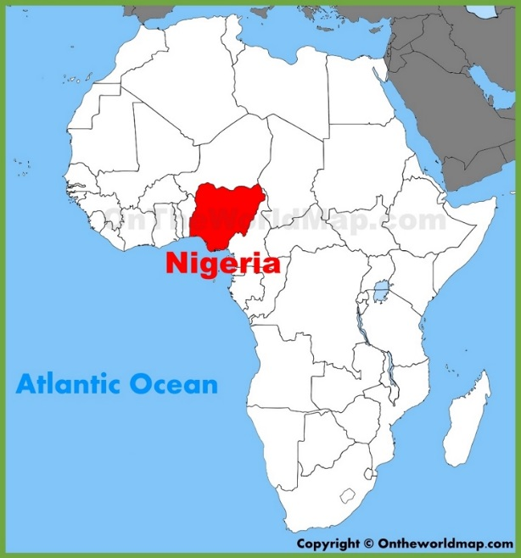

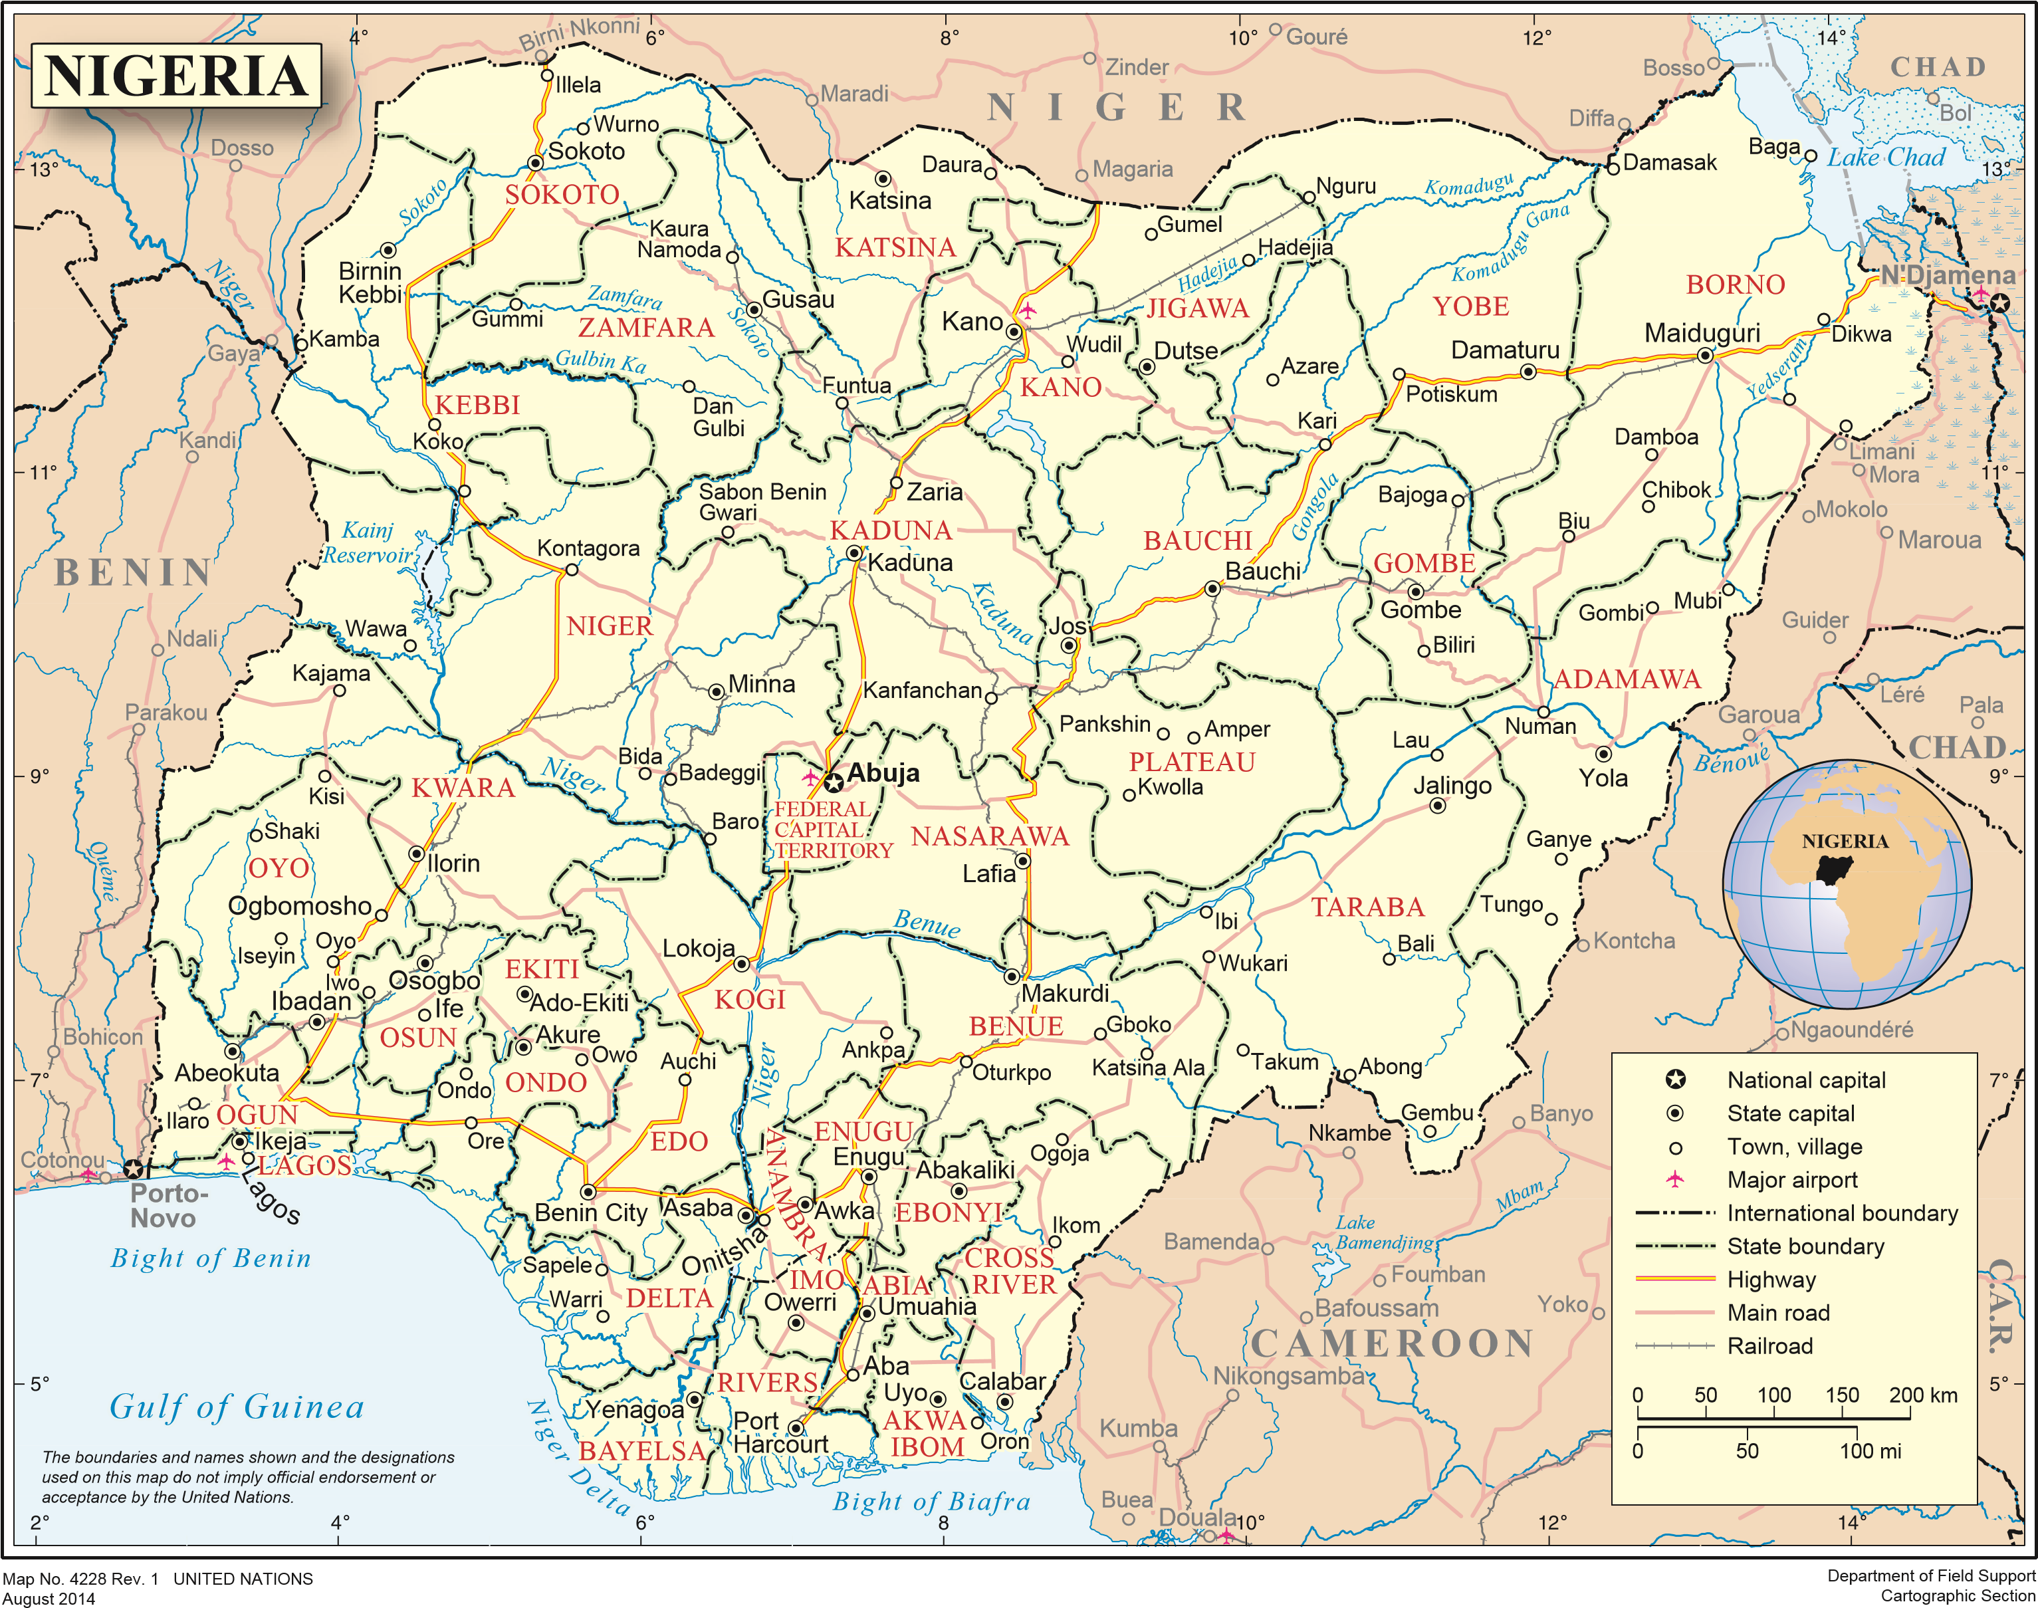

## Figure 1: Geographical Location of Nigeria in Africa

The high plateaux include the North Central Plateau, the Eastern and North Eastern Highlands and the Western Uplands. The low`lands comprise the Sokoto Plains, the Niger-Benue Trough, the Chad Basin, the interior coastal lowlands of western Nigeria, the lowlands and scarplands of south eastern Nigeria and coastlands. Most of the country’s rivers take their sources from four main hydrological basins: the North Central Plateau (Sokoto-Rima, Hadejia, Gongola, and Kaduna rivers etc.), the Western Uplands (Moshi, Awun, Ogun, Osun, Osse rivers etc.), the Eastern Highlands (Katsina-Ala, Donga rivers, etc.) and the Uri Plateau (Anambra, Imo and Cross rivers etc.).

The soils in Nigeria (see Figure 2) can broadly be categorized into four groups: sandy soils in the northern zone; lateritic soils in the interior zone; forest soils in the southern belt; and alluvial soils. The northern zone of sandy soils lies in the very northern parts of the country, particularly in the Sudan and Sahel zones. In some parts, (e.g. Kano, Kaduna and Sokoto States), they are mainly fine sandy loam soils, friable, and relatively easy to cultivate and good for agricultural crops, particularly groundnuts. In some parts of the extreme northern guinea savanna and southern Sudan savanna, (e.g. in southern Kaduna State), there is a mixture of soils disintegrated from the local granite, and loess soils brought down by winds from the north. The fertile loam soils found in the Zaria region are particularly good for agricultural crops like cotton.

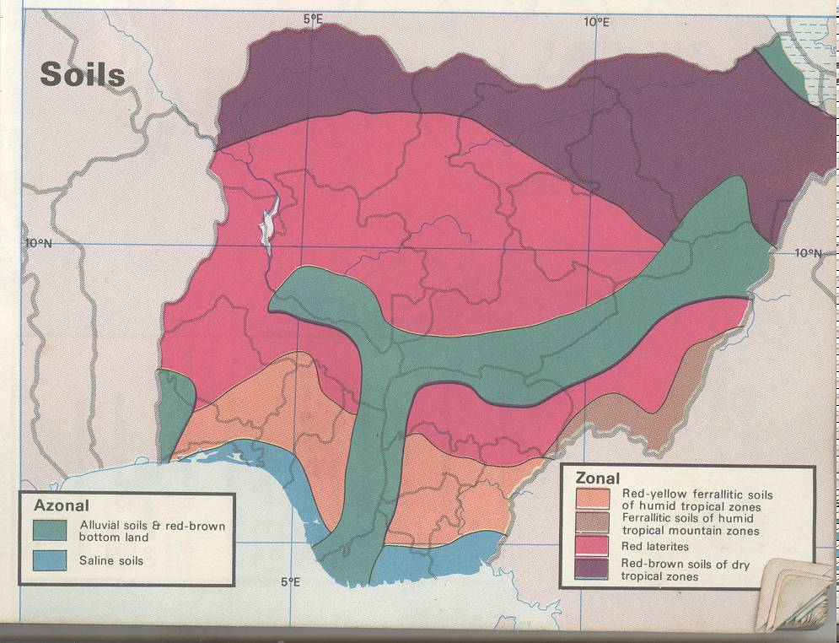

## Figure 2: Soil map of Nigeria

The interior zones of lateritic soils are generally found in the guinea savanna, deeply corroded and grey or reddish in colour. The Guinea savanna also has rich lava soils (e. g. in Biu plateau) that are productive and offer good prospects for agricultural expansion. The southern belt of forest soils coincides roughly with the high forest belt where the wet season is long; and where vegetation plays the double role of supplying humus to the soil and protecting it from erosion. The soils here are used to produce cash crops such as cocoa, palm produce and rubber. The zone of alluvial soils contains soils, which are formed by recent water deposits, and therefore are found on the flooded plains of rivers, or on deltas, or along the coastal flats. The zone extends from the coast inland, and runs along the valleys of the Niger and the Benue, thus cutting across the vegetation belts. Along the courses of rivers, the soils are sandy, and often sterile.

## Vegetation of Nigeria

The ecological zones in Nigeria are based on Keay (1949), and are defined from south to north as follows: Mangrove Swamp and Coastal Vegetation, Freshwater Swamp Forest, Lowland Rain Forest, Derived Savanna, Guinea Savanna, Sudan Savanna, and Sahel Savanna. A few mountainous areas are found in the Jos Plateau, Adamawa, Taraba and northern part of Cross-Rive State (**Figure 3**).



## Figure 3: Ecological zones of Nigeria

### Mangrove Forest and Coastal Vegetation Ecological Zone

Mangrove forest is found along the coastal and delta areas of Nigeria where the water is brackish. The most prominent feature of the mangrove forest is the stilt roots of *Rhizophora* which do not penetrate the ground but divide immediately below the water surface to form a thick felt raft of its own making. Mangroves are dominated by the following species: *Rhizophora racemosa, R. mangle, Avicennia africana* and *Laguncularia racemosa. R. racemosa* is the biggest of the R*hizophora spp,* and can attain heights of up to 40 meters and accounts for up to 95% of the species content of the mangrove forest. In Cross River State, the mangroves are threatened by the exotics Nypa Palm, *Nypa fruticans,* that wasintroduced into Calabar and Oron between 1906 and 1912. The palm tends to form pure stands and isolate endemic mangrove trees. Mangrove wood provides excellent fuel, which burns even when the wood is fresh (Udo, 1978), and because the wood is not readily attacked by termites, it is used for building, mining props and railway sleepers.

### Freshwater Swamp Forest Ecological Zone

The **freshwater swamp forest** forms a wide belt immediately inland of the mangrove and coastal vegetation, and has more open canopy (which may reach 45 m in height) and dense tangled, and almost impenetrable undergrowth. It is usually flooded during the wet season and dries out during the dry season leaving portions of dry forest floor interspersed with permanent pools of water. Much of this vegetation type has been converted to agricultural and urban lands, and the original swamp forest remains mostly on alluvial sites along the major rivers. Climbing palms with hooked spines are particularly characteristic as are clumps of large aroids such as *Cyrtospernia senegalense.* Large trees such as *Mitragyna ciliata, Spondianthus preussii, Lophira alata, Anthostema aubryanum* and *Alstonia congensis* occur with smaller trees such as *Nauclea gilletii, Berlinia spp., Grewia coriacea,* and *Uapaca spp.* A number of trees have stilted roots. The *Raphia* palm and *Lonchocarpus griffonianus* are usually abundant in the outer fringe vegetation which seldom exceeds 14 m in height. Behind the fringe, the trees of the freshwater swamp may reach 30 m in height.

### Lowland Rain Forest Ecological Zone

This Lowland Rain Forestis located north of the freshwater swamp forest and south of the Derived Savanna Ecological Zone to the north. It is an area of dense evergreen forest of tall trees with thick undergrowth consisting of three layers of trees: the emergent layer with trees more than 36 m high; the middle layer between 15-30 m; while the lowest layer is generally below 15 m. The understorey is a shrub stratum composed of single-stemmed shrubs. The forest in the northern parts of the zone is characterised by a number of species belonging to the *Sterculiaceae* family, but the *Ulmaceae* and *Moraceae* families are also common. Characteristic species of the lowland rain forest are *Terminalia superba, Ricinodendron spp.*, *Aubrevillea kerstingii* and *Khaya grandifloria.* The families *Meliaceae* and *Leguminosae* make up a large proportion of the tree species in the wetter southern areas of this zone. In still wetter areas the *Sapotaceae* are prominent and the timber trees *Lophira alata* and *Nauclea diderrichii* are often abundant. While a few areas of the rainforest remain untouched (undisturbed) with top canopy closely interlocked, most rainforest has been disturbed/degraded through conversion to agricultural farmlands, indiscriminate felling and wood removal, except for parts of the Cross River State. In some areas tropical rain forests have become limited to forest reserves, national parks and game reserves (which are also encroached). The legend classes "disturbed forest" and "undisturbed forest" were also used in the delineation of this zone.

### Derived Savanna Ecological Zone

The Derived Savanna constitute an east-west band between the Lowland Rain Forest and Guinea Savanna ecological zones, and is characterized by dense populations. The appearance and composition of derived savanna, apart from the vestiges of lowland rainforest, are much the same as in the southern areas of Guinea Savanna; but in some areas (e.g. where man’s impact on the forests has been high) there is a considerable reduction of vegetation/plant species. The impact of man has been so intense in this area that areas left to regrow tend to grow savanna type grasses, thus creating a "derived savanna". Remnants of the high forest may be present in upland or rocky areas that are not suitable for agriculture.

### Guinea Savanna Ecological Zone

The Guinea savanna (or savanna woodland/wooded savanna) is the most extensive vegetation in the middle belt of Nigeria, and consist of a mixture of trees and grass. It receives annual rainfalls between 1000 – 1500 mm with about 6-8 months of rain. It contains parkland savanna, gallery forests and derived savanna. The typical vegetation is an open woodland with tall grasses (1 to 3m high) in open areas and trees (up to 15m high) usually with short boles and broad leaves. This vegetation is burnt almost annually by fierce fires in the dry season, therefore fire-resistant species predominate.

The parkland savanna is a by-product of centuries of tree devastation by man and fire, and a continuous attempt by plants to adapt themselves to the climatic environment, by developing long tap roots and thick barks, which enable them to survive the long dry season and resist bush fires.

Species in the southern areas of the Guinea Savanna zone include *Lophira lanceolate,* *Terminalia glaucescens,* *Daniellia oliveri, Hymenocardia acida, Vitex doniana, Detarium microcarpum* and *Aftelia a.fricana.* All these species have thick bark capable of resisting grass fires. Species of the northern Guinea Savanna show close affinities with the east African "miombo" woodlands, and include, *Isoberlinia doka, ldalzielli, Monotes kerstingii* and *Uapaca togoensis.* Open canopy is dominated by grass, shrubs (e.g., *Gardenia spp.* and *Protes elliottii)* and woody climbers (e.g. *Opilia celtidifolia* and *Uvaria chamae)*.

### Sudan Savanna Ecological Zone

The **Sudan savanna** belt is found to the northern parts of Nigeria, and stretches from the Sokoto Plains through the northern section of the High Plains of Hausa land to the Chad Basin. It includes areas around Sokoto, Kaduna, Kano and Borno States of Nigeria, comprising an area over a quarter of the country. Rainfall ranges from about 600-1000 mm and the relative humidity is generally below 40%, except for the few rainy months when this can rise to 60% and above. The zone experiences a dry season of about 4-6 months. The zone has the largest population density in northern Nigeria, produces important economic crops such as groundnuts, cotton, millet, and maize and has the highest concentration of cattle in the country. Sudan savanna has consequently suffered great impact from man and livestock. The landscape has less vegetation than the guinea savanna. Existing vegetation consist mainly of short grasses, about 1-2 m high, and some stunted trees, such as acacia, the silk cotton and the baobab.

### Jos Plateau Ecological Zone

Jos Plateau Ecological Zone is based on the distinctness of the vegetation of the plateau (altitude about 1200 m) for two reasons. First, the high plateau has suffered widespread degradation by man so that only relics of Guinea woodland remain. The plateau is now almost totally treeless. Second, the flora on the plateau is peculiar with many species of woody and herbaceous plants not found elsewhere in West Africa, alongside many typical Guinea Savanna species. Species peculiar to the Jos Plateau include *Terminalia brozenii, Morea zambesiaca* and the orchids *Disperis johnstoni* and *Disa hircicornis.*

### Montane Region Ecological Zone

These highlands and plateaus are characterized by grassland vegetation at the base, forest vegetation on the windward slope and grassland vegetation on the plateaus surface. The lower slopes of highlands located in the forest belt such as Bamenda Highlands (in Cameroon) and the Obudu Hills are covered with forest vegetation, while the upper slopes and the plateau surfaces have grassland vegetation, which normally supports a cattle population.

This region is found along the southeastern border of Nigeria in the Cameroon mountains. Forest vegetation extends as high as 1600 to 2400 m where the forest stops abruptly and is replaced by mountain grassland. There are two main types of montane forest. From about 1000 to 1800 m altitude the forest is enveloped in mist for long periods and is referred to as Mist Forest. The tree canopy is irregular and is composed of species such as *Polyscias ferruginea, Entandrophragma angolense, Turreanthus africanus* and at higher altitudes *Schefflera hookeriana* and species of *Ficus* and *Conopharyugia.* The high humidity results in a profusion of mosses and various kinds of epiphytes. Above the mist zone the forest is drier, more stunted, and more susceptible to fire. Typical trees include *Syzygium standtii, Schefflera abyssinica, Schefflera mannii, Lachnopylis mannii* and *Pittosporum mannii.* Masses of lichens beard the branches of the trees. At the upper limit of the forest there is a scrubby zone of *Rapanca neurophylla, Agauria saheifolia* and *Laisiosiphon glaucus.* In the lower grasslands most of the grasses are tussocky, have flat leaves, and reach 0.6 min height, or slightly more. The family *Compositae* is well represented in this grassland. At about 3000 m there is a marked change, the flat-leaved tussocky grasses, such as *Andropogon distachvus* are replaced by grasses with more compact shorter tussocks of narrow rolled leaves, such as *Festuca abyssinica.* Trees are absent from this upper grassland, with only a few bushy plants such as *Blaeria mannii, Senecio clarenceanus* and *Helichrysum mannii.*

### Sahel Savanna Ecological Zone

The **Sahel savanna**, is found to the extreme northwest and northeast of the country, where the annual rainfall is less than 600 mm and with dry seasons exceeding 8 months. Typically the vegetation consists of grasses, open thorn shrub savanna with scattered trees, 4 to 9 m in height most of them are thorny, and extensive sparse grasses. Main tree species include *Acacia raddianna, A. Senegal, A. laeta* and *Commiphora Africana;* the shrubs are *Salvadora persica, Leptadenia pyrotechnica,* and four species of Grewia; while the grasses include *Aristida stipoides, Schoenefeldia gracilis* and *Chloris priean.* The legend class "dominantly grasses with discontinuous shrubs and scattered trees" was the primary class used to delineate this ecological zone. The class extensive small holder rainfed agriculture with denuded areas" was also common in this ecological zone.

# Scope: Activities, Pools and gases included

## Activities included

The Cancun Agreement defines REDD+ activities as follows: reduction of emissions from deforestation, reduction of emissions from forest degradation, sustainable management of forests, enhancement of forest carbon stocks, and conservation of forest carbon stocks. Deforestation is the conversion of forest land to non-forest land (cropland, grassland, settlement, wetlands and other lands). Forestland is considered as in the forest definition adopted for Nigeria (see **section 6**), and any conversion below the threshold of forest definition is considered deforestation. Forest degradation results in the loss of carbon stocks and biodiversity in the forest remaining forests category, while enhancement is the enrichment in carbon stocks and biodiversity in forest remaining forest. While forest degradation (from logging, fuel wood extraction, charcoal production, forest fires, etc.) constitute a significant source of emissions, it has not been included in the present FREL due to lack of reliable, accurate and consistent data at state and federal levels. However, it is envisaged that forest degradation will eventually be included in a stepwise manner, as data becomes available. Nigeria considers the REDD+ activity “enhancement of forest carbon stocks” to be both enrichment in carbon stocks in forest remaining forest, as well as enrichment in carbon stocks through afforestation/reforestation and natural regeneration of forest.

The country has promoted natural forest restoration and plantation silviculture that leads to reduction in emissions from deforestation and forest degradation. However, no reliable data on forest degradation is available, so this REDD+ activity has not been included in the present FREL submission. There is also no reliable data for sustainable management of forests to be included. The area of afforestation (enhancement of forest carbon stocks in forest land remaining forest land) was also assessed by Nigeria but the confidence value is currently very large and it still needs to be investigated how to assess the associated removal factor from the NFI data. Hence, only deforestation has been considered in the present FREL submission. Nigeria admits the fact that significant pools and/or activities should not be excluded from the FREL/FRL.

## Pools included

While IPCC recognises five carbon pools: above ground (live tree) biomass, belowground (live tree) biomass, deadwood (standing and lying/down), litter, and soil organic carbon; only significant pools need to be included (cf. SBSTA Decision from COP17). Key category analysis is needed to determine which carbon pools should be included to capture significant emissions and removals from changes in forest cover, taking into account their magnitude and cost-effectiveness to monitor the pools. The above-ground biomass constitutes the main component/largest pool and has been included in the FRELs/FRLs. Belowground biomass constitutes a significant pool however, its estimation is expensive and was indirectly undertaken using IPCC default root-to-shoot (R/S) ratio. With the present inventory design for national FRELs, data was collected to estimate deadwood pool. The 2006 IPCC Guidelines does not provide default values for deadwood (see Table 2.2: Chapter 2, IPCC 2006).

### Omission of litter

Litter and non-herbaceous biomass pools constitute a small proportion of biomass and has not been included. For tropical forests litter pools are usually small except for peatlands. According to the 2006 IPCC Guidelines, litter pool can be estimated at a tier 1 level for deforestation. The 2006 IPCC Guidelines provides a default value of 2.1 tC/ha for tropical broadleaf deciduous forests (see Table 2.2: Chapter 2, IPCC 2006). During the inventory undertaken, litter and non-herbaceous pool was sampled on 1m2 quadrats in some plots in the Derived Savanna, Lowland Rainforest, and Montane, and the analysis 1.61 tC/ha for Derived Savanna, 2.06tC/ha for Lowland Rainforest, 8.65 tC/ha for Montane, and 4.96tC/ha for pooled Lowland Rainforest and Montane; corresponding to2.3%, 2.1%, 7.5% and 4.9% respectively of the total live biomass estimated for the different ecological zones. These percentages are low, except for Montane, and could be omitted, given the tedious and cost incurred to sample the litter pool.

### Omission of soil organic carbon

Soil organic carbon (SOC) is an important carbon pool, however major changes only occur when forest is converted to non-forest, and over a long time. IPCC distinguishes between mineral soils and organic soils (peatlands). According to the harmonized world soil database (HWSD: Batjes, 2009) Nigeria has mainly low activity clay (LAC) soils, high activity clay (HAC) and wetland soils in the coastal region, which are mineral soils. Nigeria estimated emissions from deforestation happening on mineral soils and explored further data to confirm the absence of peatlands in the country. A recent study by Akpa *et al.* (2016) in Nigeria estimates forest soils (0-30cm) to contain 49.9 tC/ha

**Potential emissions from mineral soils**

Nigeria reviewed different literature sources which estimate the extent of peatland in the country. The estimates ranged from 120 km2-7000 km2 (Page *et al* 2011), 1,100 km2 (Joosten, 2009) and more than 21,000 km2 (CIFOR). However, the same area (**Figure 4**) also appears to be the mangrove and fresh water swamp ecological zone in Nigeria.

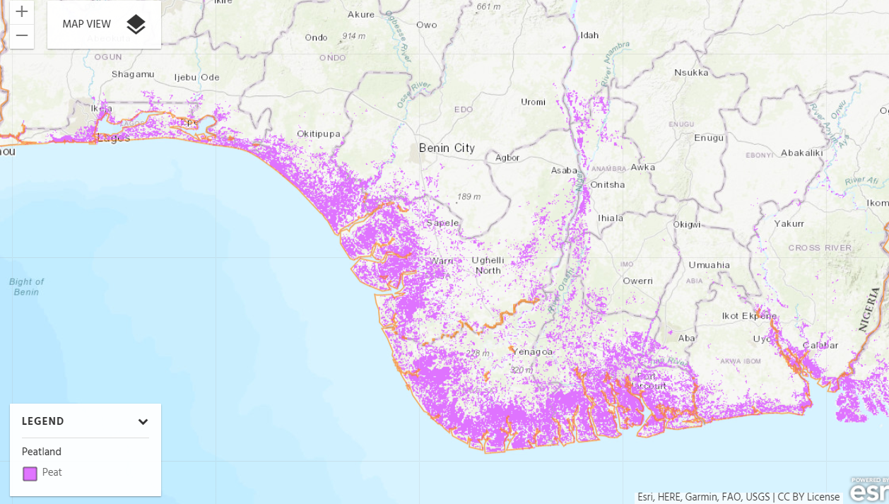

## Figure 4: Potential areas of peatlands in Nigeria (Source : <https://www.cifor.org/global-wetlands/>).

## Gases included

Among the three greenhouse gases associated with land use change emissions, namely carbon dioxide (CO2), methane (CH4), and nitrous oxide (N2O), CO2 is the main gas emitted in the forest sector. However, significant non-CO2 gases (CH4 and N2O) can also be emitted when land use change is as a result of fire incidences. Unfortunately no data exist on forest fire. However, based on our knowledge of the region we can conclude that fires are relatively controlled and not very frequent, as such emissions from fire are not expected to be significant. Methane is also produced when mangroves are disturbed, but no data exist in Nigeria at the moment. Therefore, only CO2 emissions have been considered in the present submission.

# Forest Definition

When submitting a FRELs/FRLs to the United Nations Framework Convention on Climate Change (UNFCCC), countries are expected to provide a definition of what they mean by forest in their FREL/FRL construction and, demonstrate how the definition is in line with the definition used in the national GHG inventory or in other international reporting. Forest definition in the context of REDD+ has to take into account UNFCCC thresholds which are currently defined as follows:

* Minimum tree crown cover between 10 and 30%
* Minimum land area between 0.05 and 1 hectare
* Minimum tree height between 2 and 5 meters (at maturity *in situ*)

Nigeria had no country-specific forest definition, but had been using the FAO FRA default definition for forests, which is defined as follows:

*“Land spanning more than 0.5 hectares with trees higher than 5 meters and a canopy cover of more than 10 percent or trees able to reach these thresholds in situ. It does not include land that is predominantly under agricultural or urban land use”.*

During the workshop of 24th to 26th May 2016, participants went through brain storming sessions in order to craft a forest definition for FREL purposes. An initial stage involved an appraisal of existing definitions and/or descriptions of forest in the forest laws, policies and Acts and other documents. They explored and reviewed some policy documents, at Federal and State levels, in order to have an in-depth understanding of what the law and policies documents consider as forest across the different States. Based on the above background information, participants arrived at the following functional forest definition for FREL/FRL in Nigeria.

*An ecological community predominated by trees and other layers of woody plants with a minimum area of* ***0.5ha****, a minimum tree height of* ***3metres****, and a minimum tree canopy cover of* ***15%****, or stands with potentials to reach the above thresholds in situ.*

The above Forest Definition applies to the entire country and was provided after due consideration for the ecological variations including the characteristic strong latitudinal zones which become progressively drier as one moves north from the coast. In other words, the definition has to a large extent, taken care of the progressive variations from the Mangrove Swamp and Coastal Vegetation in the south to the Sahel Savanna in the north. It is important to note that, the definition would be used in future GHG inventory reporting such as national communications and the Biennial Update Reports (BUR).

Further details on the consultations and processes undertaken to arrive at the forest definition were detailed in the sub-national FREL submitted by Nigeria to UNFCCC in January 2018.

# Estimation of Historical Emissions

IPCC (GPG 2003 and Guidelines for National GHG Inventories in AFOLU, 2006) provides the framework for estimating emissions and removals of CO2 in the AFOLU sector. Two basic inputs needed are: Activity data (AD: i.e. changes in areal extent of forest land (ha/year)) and emission factors (EF: that is, emissions/removals of GHG per unit area: tCO2/ha of deforestation). The product of AD by EF produces an estimate of the amount of emissions/removals in a given year as a result of the activity.

IPCC present three approaches (1-3) for estimating AD and three Tiers (1-3) for estimating EF. The estimation of historical emissions therefore requires estimates of historical activity data and emission factors.

## Activity Data

Activity data is mostly obtained from land use change studies using satellite imagery. Several land use studies have been undertaken in Nigeria; however, their use is limited due to the fact that they were sample-based (not ‘*wall-to-wall’*), and used different methodologies and classification systems. The only study that produced wall-to-wall estimates of land use change was the 1976/78 and 1993/95 Vegetation and Land use Assessment by FORMECU, Federal Department of Forestry. The study also produced a national classification system for Nigeria that is being used for reporting of global forest assessment (e.g. FRA2015 for Nigeria). These datasets are also outdated and obsolete.

### Description of Land use land use/land cover classification scheme for Nigeria

The classification system adopted is based on a national land use and cover classification scheme developed in 1995 mapping project in Nigeria (FORMECU, 1995), and drawing from the work of Beak Consultancy in 1975/76. The classification consisted of 36 land use/land cover classes, but it was deemed necessary to aggregate the classes into a few easily mappable classes that can be distinguished with high confidence on satellite imagery. In consultation with relevant stakeholders working in the land base sector in Nigeria (e.g. NASDRA: the National Space Development and Administration Agency (NASRDA), the 36 classes were aggregated into 12 classes which were further grouped into forest and non-forest classes. The forest classes include, undisturbed forest, disturbed forest, mangroves, forested freshwater swamp forest, and forest plantation. The non-forest classes include arable cropland, grassland, savannah woodland, tree crop plantation, settlements, bare surfaces and water bodies. Figure… below shows the reclassified FORMECU (1995) using the 12 land use classes, followed by brief descriptions of the classes.

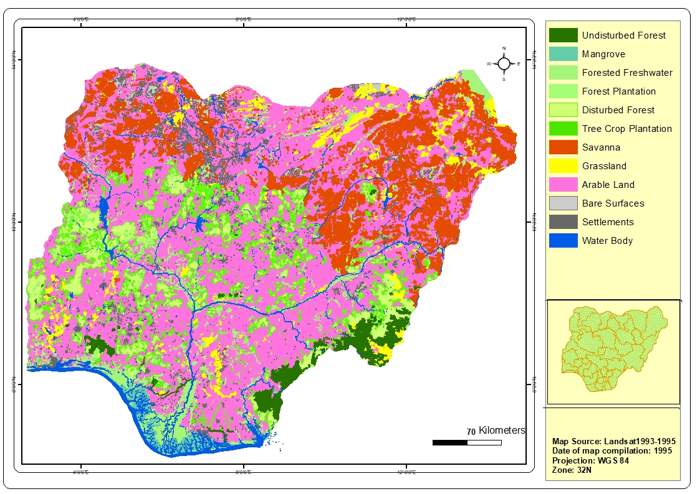

## Figure 5: Nigeria Land cover 1995 (Source: FORMECU)

***Undisturbed Forest:*** This forest types include high forest of evergreen *hyrophlytic* (water tolerant) plant of high species diversity, the canopy can be of three layers with the topmost (emergent layer ) of 24-50 meters high which may consist of scattered, very tall trees that do not form a continuous canopy. The middle layer (16-40 m high) is also discontinuous but taken together with the upper layer form a continuous canopy. The lower tree layer (10- 16m high) forms a more or less continuous canopy. Below the trees are the shrubs and herbs layers that contain young trees and seedlings. The canopy closure is at least 70%. This could be found mainly in the southern Nigeria.

***Disturbed Forest****:* The forest type is similar to the undisturbed forest except that it has been degraded by cultural activities. The canopy can be two or three layers but usually the topmost layer comprises of scattered trees and the canopy closure is between 30% and less than 70%. This is usually referred to secondary vegetation as it can include abandoned farmlands and fallow lands

***Freshwater Swamp****:* This land cover types comprise of all type of vegetation along the freshwater river banks and marshy areas. The canopy closure can range between 60 to 100 percent depending on the nature of cultural activities taking place. They are usually inaccessible for logging but fuel wood harvest is common. They be found in the lower course of the big river channel. The signatures in the medium resolution images are similar to the disturbed forest but they are usually found in close proximity to fresh water river channels.

***Mangrove Forest:***  mangrove forest is marine vegetation type found in close proximity to the ocean, creeks and esturaries. They can be pure stand or with mixture of other vegetation such as nypa palm raphia and other vegetative bluff. The canopy closure is usually between 30 and 70% depending in the nature of logging activities taking place in the creeks.

***Forest Plantation:*** This represents forest cover that was planted for commercial logging or conservation purposes. It includes both public and private owned forest plantation estate scattered across the country especially in the southern parts of the country. The signatures of forest plantation on the images are similar to the disturbed forest or tree crop plantation but the canopy closure usually ranges between 60 and 70% and can contain one or more layers. The canopy closures in matured forest plantation can be less due to logging and fuel wood harvesting

***Montane Forest****:* This type of forested vegetation is found in very high altitude (3500 to 6000 feet) and is similar to temperate vegetation. The forest is characterized by irregular tree canopy, discontinuous and broken. The associated plants are various kinds of epiphytes such as orchids and begonias. The canopy closure can range between 30 to 70%. Montane forest is found mainly on the Nigeria-Cameroon borders in Taraba and Adamawa States, and to the north of cross-River State.

***Arable Cropland***: This type of land cover represents all cropland for arable agriculture. They are represented by regular boundaries of cultivation and are distinct from fallow land and secondary vegetation. This is one of the most varied land use classes in the country. The crops often grown include millet, sorghum, and maize in the northern parts of Nigeria, while yam, cocoyam, and cassava, intermixed with maize are the dominant crops in the southern part of Nigeria. The land use and cover types include intensive row crops with minor grazing, large assemblages of small plot farms. The signature of cropland varies markedly as you progress from south to the north.

***Savanna Woodland/shrub:*** This non forest class is mainly found in the Guinea and Sudan Savanna ecological zones of Nigeria. It includes grasslands but with scattered trees. The presence of trees can range between 4 to 10 trees per hectare. They have signatures that are very similar to grassland and bare land depending on the period or seasons of data capture.

***Grassland:*** This non forest class represent continuous grassland often interspersed with patches of bare soil. It is predominant in most parts of northern Nigeria especially where overgrazing and wood harvest have degraded savannah woodland to largely grassland; and where erosion processes can further degrade them to bare land.

***Tree Crop Plantation****:* Tree crop plantations are characterized by regular boundaries similar to arable crop land but usually have very tall tree crop and have two or three layers of vegetal storey’s. The tree crop plantation includes cocoa, rubber and palm plantations, mostly found in the southern rainforest, mangrove and freshwater swamp areas. The signatures on the satellite images are similar to disturbed forest but they could be distinguished by their regular shaped boundaries. A typical tree crop plantation can have a canopy closure of up to 70% depending on the nature of the tree crop and the farming system used.

***Bare land****:* This class represent land surfaces with no plant cover. It may be covered with aeolian deposits or sand dunes; or could be an overgrazed area or area of massive wind or water erosion.

***Settlements****:* Settlements represent human habitation in form of villages, towns and cities which are scattered all over the country and have signatures of very high tones. The signatures of the roof tops of cities in the southern part of Nigeria especially the older part of the city is relatively brownish while the tone in the northern parts are greyish.

***Water bodies:*** This class represents all bodies of water. Where water cover large surface area and usually have dark tones signature. However, it may have lighter tone in areas where there is high siltation or high pollution. Flooded water body may also have different signatures.

### Production of Land use/Land cover Maps, change detection and Accuracy Assessment

***Land use/Land cover mapping:***

The 12 classes described above were used in the classification using the FAO open source tools (SEPAL, SEPAL CEO and Collect Earth). During their working session at Nasarawa Geographical Information Service (NAGIS), map mosaics were produced using the rich cloud-based SEPAL spatial database to extract relatively cloud-free Landsat imagery for four epochs (2000-2006-2010-2016)[2]. The flow chart below summarises the steps adopted in the production of land use land cover maps.

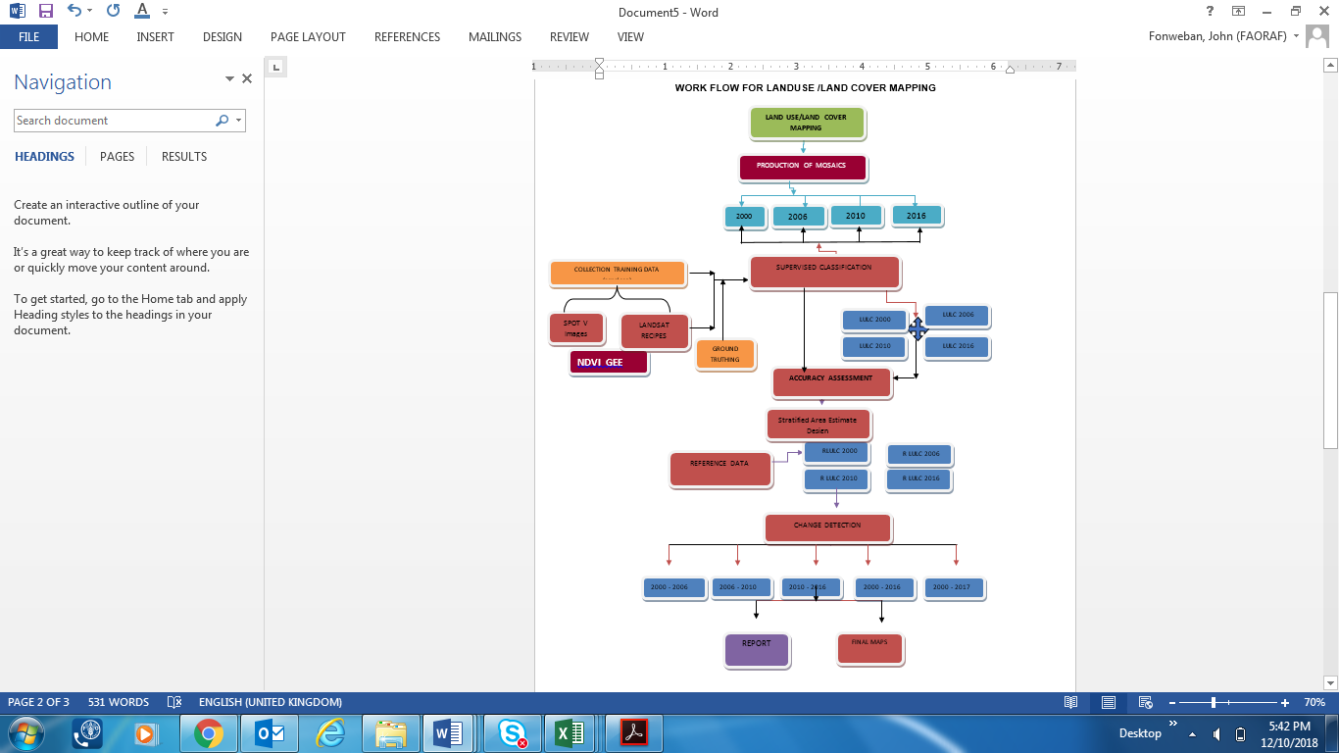

## Figure 6. Flow chart for the land use/land cover map production and Accuracy Assessment

In order to produce the mosaics, satellite imagery archives (notably, Landsat imagery) were explored and relatively cloud-free tiles extracted from SEPAL, covering the entire Nigeria. The process required initial exploration of SEPAL satellite imagery archives for the years 2000, 2006, 2010 and 2016. Threshold for cloud cover were set to between 10 to 15%, although in some cases, this was extended to 20% (e.g. in the southern coastal areas). January and February were selected as potential cloud-free periods of the year. However, despite these measures to minimise cloud-cover it was still difficult to avoid the cloud problem, especially in the southern parts of Nigeria around Port-Harcourt and Lagos that have persistent cloud throughout the year. This impacted on the actual land cover/land use areas and especially on the change detection assessment.

***Training data collection***

The procedures available in the SEPAL Collect Earth Online (SEPAL-CEO) were used to collect training dataset from 1200 points across the 12 land use/land cover classes using higher resolution imagery in SEPAL. The data was used to undertake unsupervised classification of the mosaics.

However, these maps revealed certain inconsistencies with some classes on the images that required field verification or ground truthing: for example, on the higher resolution images there were still difficulties differentiating between tree crop plantation and forest plantations in the southern forest belt; and between Savana and the Arable crop land, and grassland and Arable land in the middle belt and the northern parts of Nigeria. Consequently, ground truthing/field checks were undertaken in the Niger and Nasarawa states in the northern savannah zones of Nigeria and in Oyo and Ogun states in the forest zone. A total of 67 points were visited in the areas where unresolved issues were identified. The data collected was used to improve on the training data set in SEPAL CEO contained in the fusion table in the Google Earth Engine. The combined data was used to reclassify the images extracted from SEPAL into the 12 major classes. The figures below show final land use/land cover maps obtained from the classification for years 2000-2006-2010-2016 & 2017.

### Global Trends and Change Detection Analysis

The land use land cover maps were downloaded from SEPAL and uploaded into Idrisi environment from where change detection analysis were undertaken to determine changes between years 2000 and 2016, and 2006 and 2016, and has been detailed in a separate report. However, for the purposes of FREL construction the period 2006-2016 was adopted. Figures 7 and 8 show Land use/Land cover maps for Nigeria for 2006, and 2016 respectively.

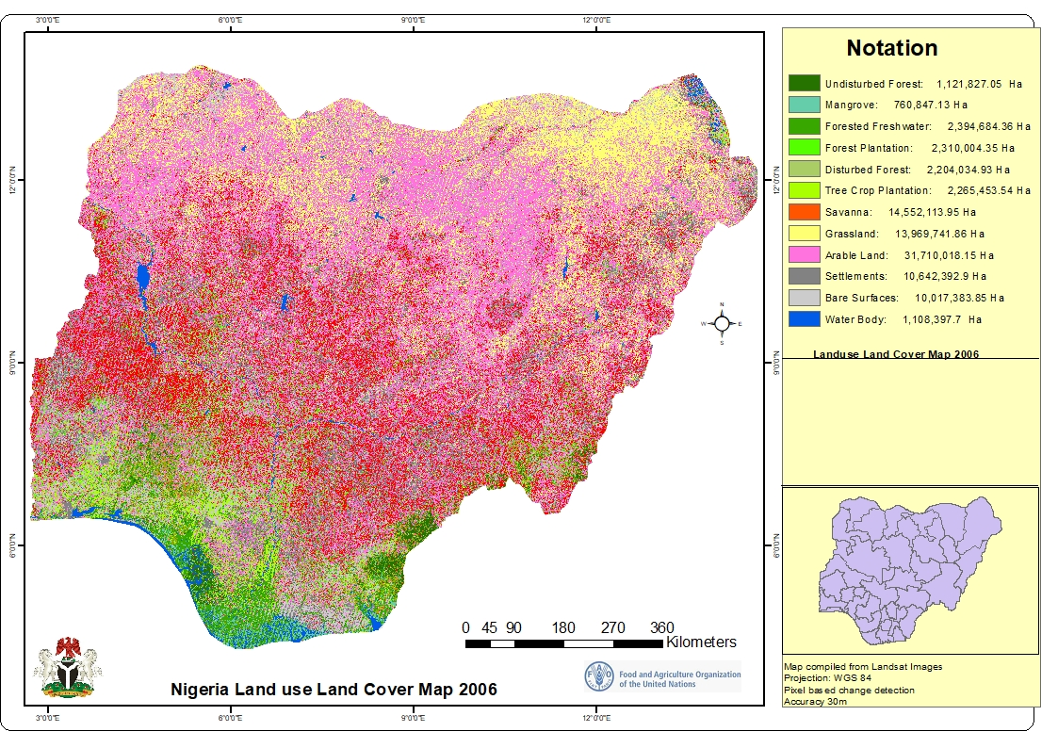

## Figure 7. Land use/Land cover map for Nigeria (2006).

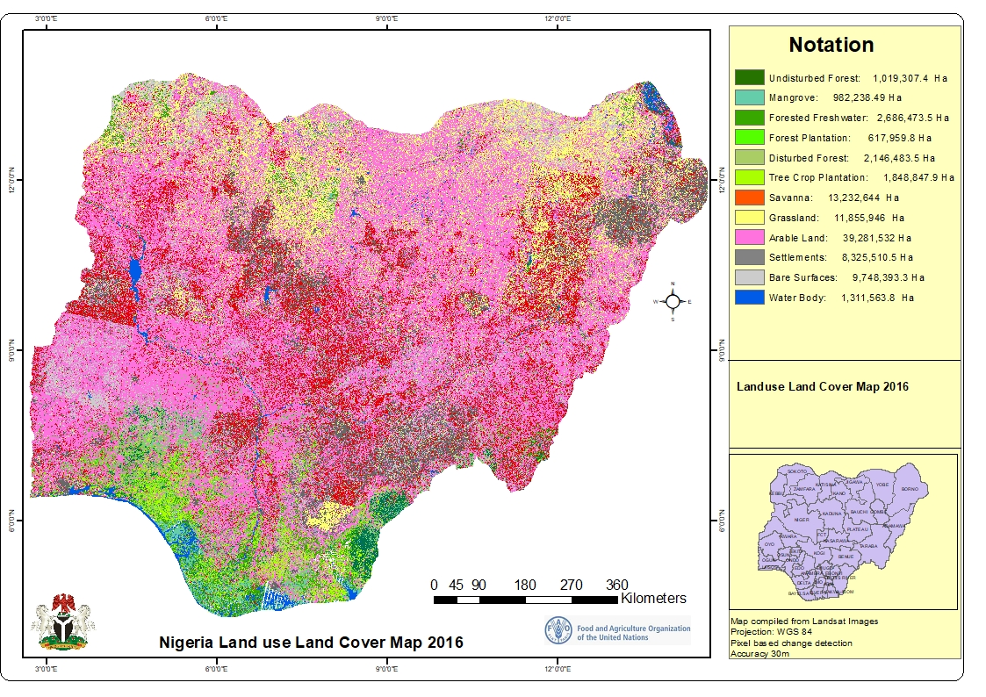

## Figure 8. Land use/Land cover map for Nigeria (2016).

**Table 1** shows land use areas for 2006 and 2016 maps and annual changes (ha/yr) within this period. From the table it can be observed that Forest classes constituted barely 9.5% in 2006 and that this areas reduced to 8.0% in 2016, while non-forest increased from 90.5% to 92% within the same period. Undisturbed forest reduced from 1.2% to 1.1%, while mangroves (2.57%) and forested fresh water swamps (0.82%) have increased to 1.06% and 2.89%, respectively in 2016. Forest plantations have reduced considerably from 2.48% in 2006, to 0.66% in 2016, while Disturbed forest has slightly reduced form 2.37% in 2006 to 2.31% in 2016. Within the non-forest land use categories, Arable Land shows considerable increase from 34% in 2006 to 42.2% in 2016; while Savanna woodland and Grassland show deceases, most probably being converted to Arable land. **Figure 9** shows the predominance of Arable land in the trend analysis.

|  |  |  |  |  |  |
| --- | --- | --- | --- | --- | --- |
| **Land use/Land cover** | **2006 Area (ha)** | **Area (as % of total land area)** | **2016 Area (ha)** | **Area (as % of total land area)** | **Annual Change (ha/yr)** |
| Undisturbed Forest | 1121827.1 | 1.21% | 1019307.4 | 1.10% | -10252.0 |
| Mangrove | 760847.1 | 0.82% | 982238.5 | 1.06% | 22139.1 |
| Forested freshwater | 2394684.4 | 2.57% | 2686473.5 | 2.89% | 29178.9 |
| Forest Plantation | 2310004.4 | 2.48% | 617959.8 | 0.66% | -169204.5 |
| Disturbed Forest | 2204034.9 | 2.37% | 2146483.5 | 2.31% | -5755.1 |
| **Total Forest** | **8791397.8** | **9.45%** | **7452462.8** | **8.01%** | **-133893.5** |
| Tree Crop Plantation | 2265453.5 | 2.43% | 1848847.9 | 1.99% | -41660.6 |
| Savanna | 14552114.0 | 15.64% | 13232643.7 | 14.22% | -131947.0 |
| Grassland | 13969741.9 | 15.01% | 11855946.2 | 12.74% | -211379.6 |
| Arable Crop Land | 31710018.2 | 34.08% | 39281531.7 | 42.21% | 757151.4 |
| Settlements | 10642392.9 | 11.44% | 8325510.5 | 8.95% | -231688.2 |
| Bare Surfaces | 10017383.9 | 10.76% | 9748393.3 | 10.48% | -26899.1 |
| Water Bodies | 1108397.7 | 1.19% | 1311563.8 | 1.41% | 20316.6 |
| **Total Non Forest** | **84265502.0** | **90.55%** | **85604437.0** | **91.99%** | **133893.5** |
| **Total Area (ha) Nigeria** | **93056899.8** | **100.00%** | **93056899.8** | **100.00%** |  |

## Table 1. Land use/land cover areas and annual changes

## Figure 9. Annual land use/land cover changes (ha/yr.)

Further understanding of the dynamics between the land use/land cover classes were explored using the transition matrices (**Tables 2 & 3**).

From the transition Matrix (**Table 3**), most losses from undisturbed forest may have been to mangroves (0.214%), FWS (0.291%) and Disturbed Forest (0.260%, as well as to Tree Crop Plantation (0.155%). Even though Undisturbed Forest might have received 0.341% and 0.319% from Disturbed Forest and FWS respectively, this did not compensate for all, losses, hence resulting in a decrease in Undisturbed Forest. Mangroves on the other hand might have received more from Undisturbed Forest (0.214%), FWS (0.490%) and Disturbed Forest (0.105%), than it lost to FWS (0.271%), Arable Land (0.114%) and Tree Crop Plantation (0.105%); thus resulting in an increase. Similarly, FWS might have received more from Undisturbed Forest, Mangroves, Disturbed Forest, Tree Crop Plantations, Grasslands, Arable Crop Land and bare surfaces, than it lost to Undisturbed Forest, Mangroves, Disturbed forest, Tree Crop Plantations and Arable Land. Most of the losses in Forest Plantations were conversions to Arable Land (1.81%), which were not compensated by the establishment of new ones. The slight decrease in Disturbed may be due to its conversion to Arable Land (0.969%), Savanna (0.331%), Tree Crop Plantation (0.355%), FWS (0.292%) and Undisturbed Forest (0.341%).

Most of the conversions/transitions occurred in the non-forest land use/land cover categories; with the most common **class of origin (cf. FAO 1996)** where changes occurred being Arable Land (25.49%), followed by Savanna (17.43%), Grassland (15.19%), then Bare Surfaces (13.52%) and Settlement (13.42%) (see **Table 4**). The most common **destination of change** is Arable Land (**37.42**%), followed by Savanna (**15.35**%), Bare Surfaces (**13.13%)** and Grassland (11.87%). The most important **class-to-class transitions** are Savanna ⇨ Arable Land (10.06%), Grassland ⇨ Arable Land (9.02%), Arable Land ⇨ Savanna (7.32%), and Arable Land ⇨ Grassland (7.70%), Bare Surfaces ⇨Arable Land (6.73%), and Settlements ⇨ Arable Land (6.68%). Generally, because most conversions are to Arable Land, the resulting plot (**Figure 9**) shows considerable increase in this land use class.

The use of flux diagrams (**Figure 10**) further attempts to explain the possible transitions/dynamics between land use types. For the entire country, the major negative transitions (emissions) are from Savanna Woodland to Arable Crop Land (10.06%), Grassland to Arable Crop Land (9.02%), Arable Land to Bare Surfaces (4.65%), and Arable Land to Settlement (3.85%); while the positive transitions (removals/absorptions) are from Arable Crop Land to Grassland (7.70%), Arable Crop Land to Savanna Wood land (7.32%).

|  |  |  |  |  |  |  |  |  |  |  |  |  |  |  |
| --- | --- | --- | --- | --- | --- | --- | --- | --- | --- | --- | --- | --- | --- | --- |
| Land Use Class | UF | MAN | FWS | FP | DF | TCP | SW | GL | AL | SET | BS | WB | Total_2006 | % |
| Undisturbed Forest[UF] | 298493.6 | 135794.9 | 185076.9 | 18987.3 | 164984.9 | 106650.0 | 42310.8 | 955.6 | 98188.9 | 6502.7 | 25181.7 | 28637.0 | 1111764.4 | 1.20 |
| Mangrove[MAN] | 51356.7 | 182176.7 | 172157.3 | 12093.8 | 55653.1 | 66798.9 | 24513.4 | 3093.2 | 72535.6 | 6915.2 | 24869.5 | 62751.8 | 734915.3 | 0.79 |
| Freshwater Swamp[FWS] | 202681.4 | 311036.4 | 536074.4 | 64551.8 | 328798.5 | 380228.3 | 93843.2 | 4277.7 | 308794.9 | 16139.9 | 56199.7 | 47223.3 | 2349849.3 | 2.53 |
| Forest Plantation[FP] | 7941.0 | 8790.0 | 40541.2 | 27802.5 | 74979.4 | 54490.7 | 469355.4 | 66430.4 | 1150119.3 | 194741.7 | 209775.1 | 2637.9 | 2307604.5 | 2.48 |
| Disturbed Forest[DF] | 216681.9 | 66442.0 | 185440.1 | 58963.3 | 423212.3 | 225557.9 | 210206.9 | 9748.6 | 615162.8 | 47825.0 | 122647.1 | 8218.4 | 2190106.3 | 2.36 |
| Tree Crop Plantation[TCP] | 60704.4 | 34820.1 | 194780.8 | 103628.2 | 175627.6 | 249472.6 | 270839.8 | 54883.4 | 856599.8 | 107774.8 | 138783.9 | 10007.8 | 2257923.2 | 2.43 |
| Savanna Woodland[SW] | 31970.4 | 18554.0 | 66515.0 | 34626.0 | 166167.6 | 51379.4 | 3481411.3 | 820058.5 | 6390061.7 | 1800767.9 | 1664678.1 | 23030.9 | 14549220.9 | 15.66 |
| Grassland[GL] | 350.0 | 2287.7 | 313318.1 | 943.6 | 3478.4 | 801.0 | 1104579.4 | 4317881.0 | 5727736.2 | 684219.4 | 1746763.4 | 66756.8 | 13969114.8 | 15.04 |
| Arable Land[AL] | 39305.2 | 36916.8 | 482428.4 | 87784.8 | 263366.8 | 202101.8 | 4647562.0 | 4892864.0 | 15512093.8 | 2443916.1 | 2955018.1 | 139287.2 | 31702645.1 | 34.13 |
| Settlements[SET] | 19012.3 | 22844.2 | 91081.7 | 44108.6 | 122080.3 | 81111.2 | 1673974.5 | 815192.6 | 4242549.8 | 2111893.7 | 1383196.1 | 31161.5 | 10638206.6 | 11.45 |
| Bare Surfaces[BS] | 80391.9 | 79494.8 | 352027.8 | 163202.2 | 360424.4 | 425152.8 | 1197937.6 | 862589.3 | 4273331.0 | 728206.2 | 1407626.6 | 65747.9 | 9996132.4 | 10.76 |
| Water Bodies[WB] | 10259.2 | 83007.8 | 66868.7 | 1248.3 | 7464.9 | 5036.0 | 15511.9 | 7773.0 | 32408.9 | 14628.1 | 13273.6 | 825818.5 | 1083298.8 | 1.17 |
| Total_2016 | 1019147.9 | 982165.5 | 2686310.4 | 617940.5 | 2146238.3 | 1848780.6 | 13232046.2 | 11855747.4 | 39279582.5 | 8163530.7 | 9748012.6 | 1311279.0 | 92890781.6 | 100 |
| Percent | 1.10 | 1.06 | 2.89 | 0.67 | 2.31 | 1.99 | 14.24 | 12.76 | 42.29 | 8.79 | 10.49 | 1.41 | 100 |  |

## Table 2: Transition Matrix for land use/land cover for 200-2016.

|  |  |  |  |  |  |  |  |  |  |  |  |  |  |  |
| --- | --- | --- | --- | --- | --- | --- | --- | --- | --- | --- | --- | --- | --- | --- |
| Land Use Class | UF | MAN | FWS | FP | DF | TCP | SW | GL | AL | SET | BS | WB |  | Total_2006 |
| Undisturbed Forest[UF] | 0.000 | 0.214 | 0.291 | 0.030 | 0.260 | 0.168 | 0.067 | 0.002 | 0.155 | 0.010 | 0.040 | 0.045 | 720654 | 1.280 |
| Mangrove[MAN] | 0.081 | 0.000 | 0.271 | 0.019 | 0.088 | 0.105 | 0.039 | 0.005 | 0.114 | 0.011 | 0.039 | 0.099 | 799989 | 0.870 |
| Forested Freshwater Swamp[FWS] | 0.319 | 0.490 | 0.000 | 0.102 | 0.518 | 0.599 | 0.148 | 0.007 | 0.486 | 0.025 | 0.088 | 0.074 | 2150236 | 2.856 |
| Forest Plantation[FP] | 0.013 | 0.014 | 0.064 | 0.000 | 0.118 | 0.086 | 0.739 | 0.105 | 1.811 | 0.307 | 0.330 | 0.004 | 590138 | 3.589 |
| Disturbed Forest[DF] | 0.341 | 0.105 | 0.292 | 0.093 | 0.000 | 0.355 | 0.331 | 0.015 | 0.969 | 0.075 | 0.193 | 0.013 | 1723026 | 2.782 |
| Tree Crop Plantation[TCP] | 0.096 | 0.055 | 0.307 | 0.163 | 0.277 | 0.000 | 0.426 | 0.086 | 1.349 | 0.170 | 0.218 | 0.016 | 1599308 | 3.162 |
| Savanna Woodland[SW] | 0.050 | 0.029 | 0.105 | 0.055 | 0.262 | 0.081 | 0.000 | 1.291 | 10.060 | 2.835 | 2.621 | 0.036 | 9750635 | 17.425 |
| Grassland[GL] | 0.001 | 0.004 | 0.493 | 0.001 | 0.005 | 0.001 | 1.739 | 0.000 | 9.018 | 1.077 | 2.750 | 0.105 | 7537866 | 15.195 |
| Arable Land[AL] | 0.062 | 0.058 | 0.760 | 0.138 | 0.415 | 0.318 | 7.317 | 7.703 | 0.000 | 3.848 | 4.652 | 0.219 | 23767489 | 25.490 |
| Settlements[SET] | 0.030 | 0.036 | 0.143 | 0.069 | 0.192 | 0.128 | 2.635 | 1.283 | 6.679 | 0.000 | 2.178 | 0.049 | 6051637 | 13.424 |
| Bare Surfaces[BS] | 0.127 | 0.125 | 0.554 | 0.257 | 0.567 | 0.669 | 1.886 | 1.358 | 6.728 | 1.146 | 0.000 | 0.104 | 8340386 | 13.522 |
| Water Bodies[WB] | 0.016 | 0.131 | 0.105 | 0.002 | 0.012 | 0.008 | 0.024 | 0.012 | 0.051 | 0.023 | 0.021 | 0.000 | 485461 | 0.405 |
|  | 813271 | 552739 | 1813775 | 2279802 | 1766894 | 2008451 | 11067810 | 9651234 | 16190551 | 8526313 | 8588506 | 257480 | 63516825 |  |
| Percent_2016 | 1.135 | 1.259 | 3.385 | 0.929 | 2.713 | 2.518 | 15.351 | 11.868 | 37.419 | 9.528 | 13.131 | 0.764 |  | 100.000 |

## Table 3: Percentage changes for land use/land cover for 2006-2016 for Nigeria.

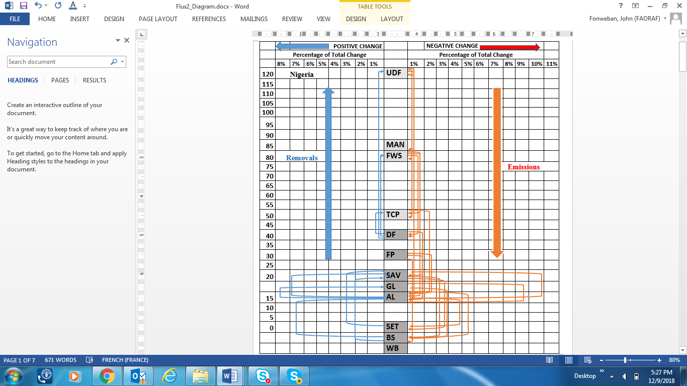

## Figure 10. Flux diagram for the main transitions between land use types for the period 2006-2016.

The analysis above for the entire country (Nigeria) may not clearly reflect reality in terms of land use transitions between 2006 and 2016. Further insights could be gained if the analysis were done by major ecological zones. The country was therefore divided into the Northern (Sudan & Sahel) zone, the Middle (Derived Savanna, Guinea Savanna and Montane) zone, the Low land Rainforest zone and the Coastal (Mangrove & Forested Freshwater Swamp) zone (**Figure 11**), and similar change analysis were undertaken as for the entire country. However, the details are presented in the Appendix to this document, while only main trends (**Figure** **12**), and flux diagrams (conceived from transition matrices) are presented below (**Figures** **13 to 16**), including brief descriptions of main transitions. The trends (**Figure 12**) do not seem to be the same in different ecological zones; however, Arable land seems to be the predominant **destination** land use, a reflection of the increasing population in quest for more farmland.

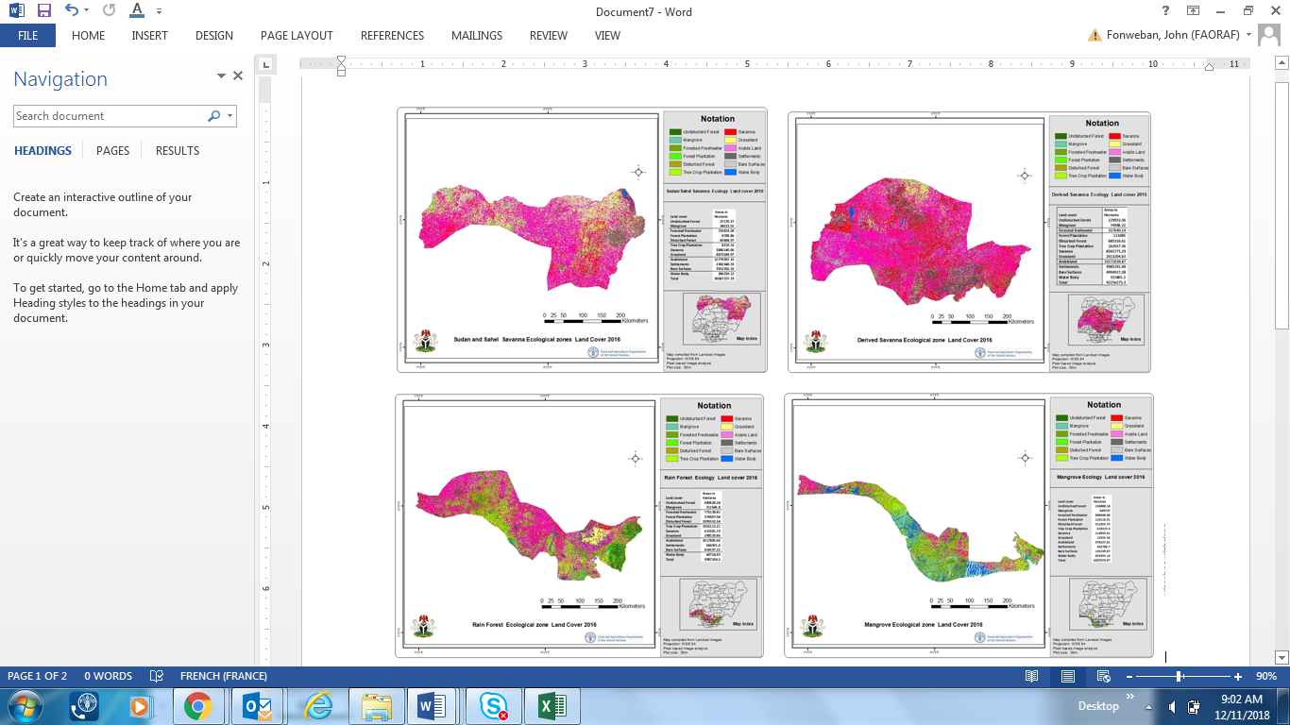

|  |  |  |  |  |  |  |  |
| --- | --- | --- | --- | --- | --- | --- | --- |
|  | |  |  |  |  |  |  | | --- | --- | --- | --- | --- | --- | |  | |  |  |  |  | | --- | --- | --- | --- | |  | |  |  | | --- | --- | |  | Figure 11. Country division by major ecological zones. | |      Figure 12. Trends in land use/land cover changes for Nigeria, and by major zones in Nigeria (blue arrows show removals while red arrows indicate emissions). | |

## Figure 13. Flux diagram for the main transitions between land use types for the Sudan and Sahel Savanna for the period 2006-2016.

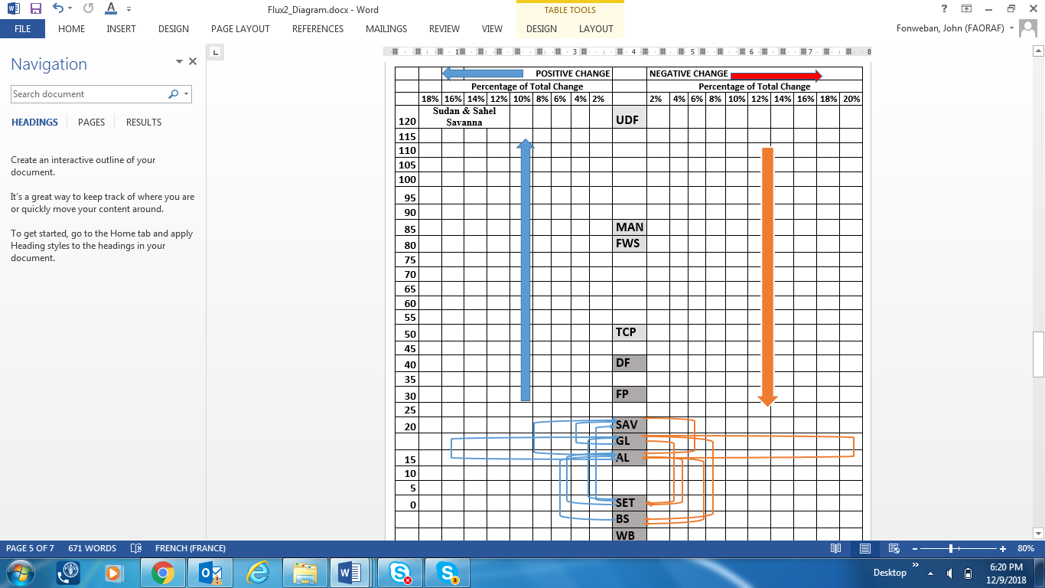 

## Figure 14. Flux diagram for the main transitions between land use types for the Guinea and Derived Savanna for the period 2006-2016.

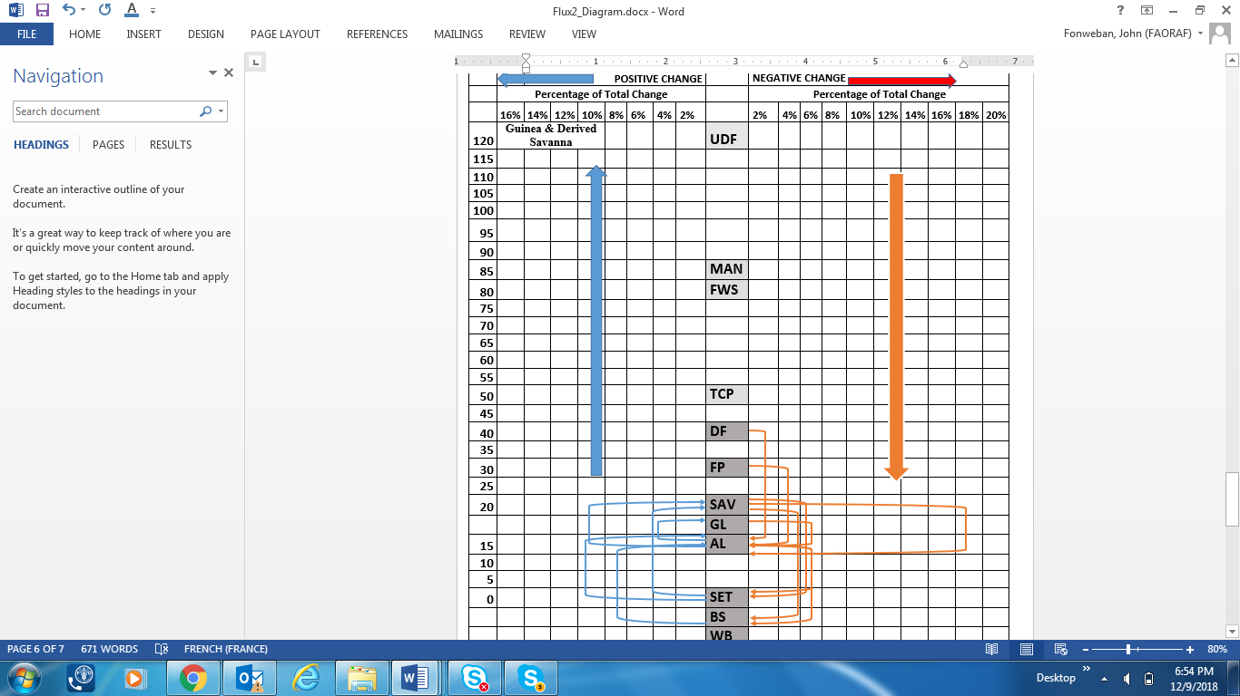 

## Figure 15. Flux diagram for the main transitions between land use types for the Lowland Rainforest for the period 2006-2016.

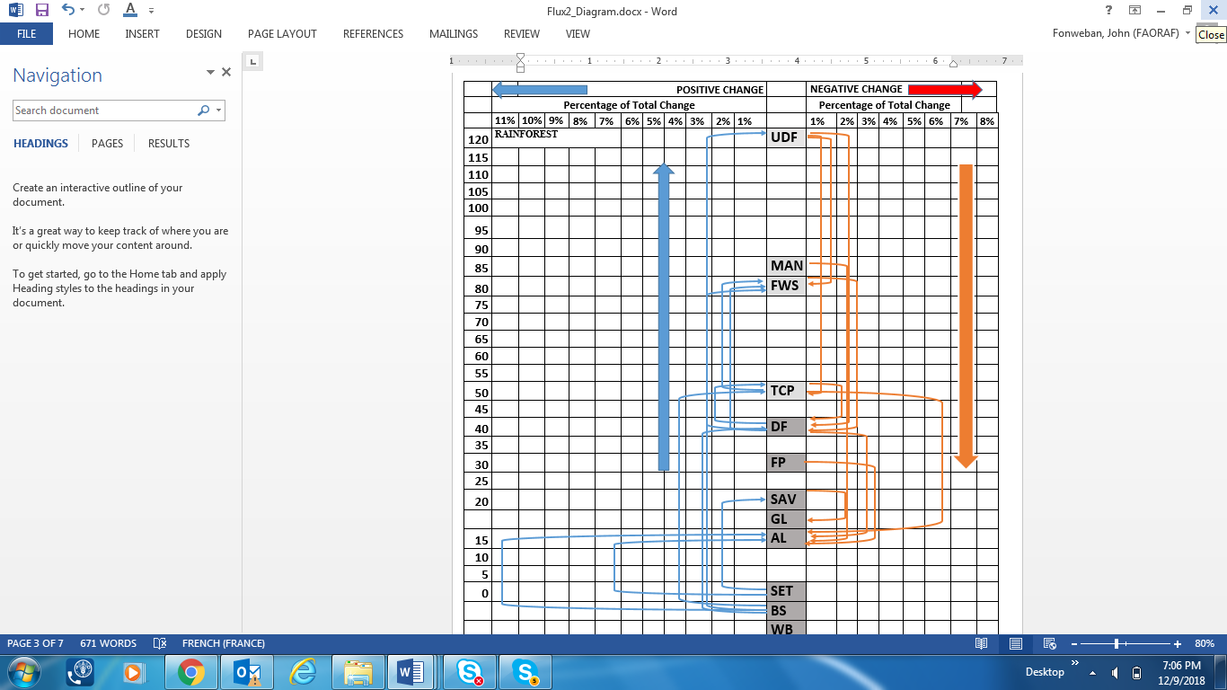 

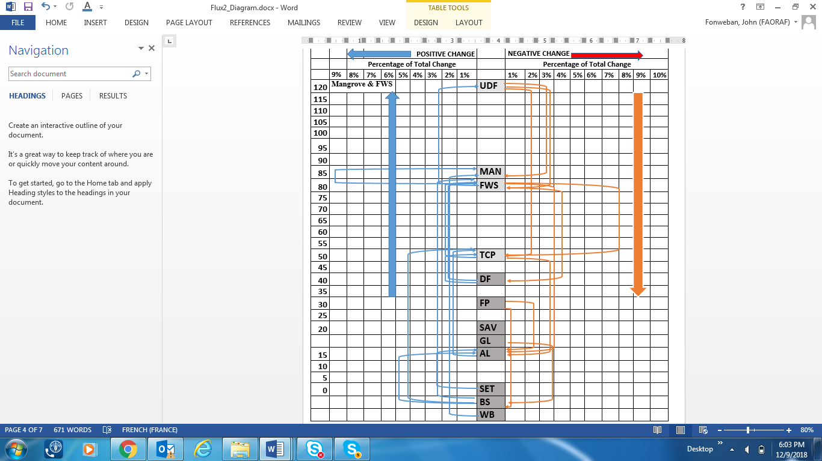 

## Figure 16. Flux diagram for the main transitions between land use types for the Mangrove and Freshwater swamps for the period 2006-2016.

### Accuracy Assessment:

Accuracy Assessment used area statistics based on reference data following the procedure described in Olofsson et *al* (2014). The method uses one of the maps to stratify the reference data points to be collected to ensure sufficient representation in the rare classes of change (forest loss and forest gain); and the resulting statistics are referred to as stratified area estimators. Reference data was obtained through interpretation of satellite data of greater quality with respect to both resolution and accuracy than remote sensing-based map data. Nigeria used all available imagery of high resolution in SEPAL, up to 2018. GFOI (2016) suggests that for accuracy assessment and estimation to be valid for an area of interest (AOI) the reference data must be collected using a probability sampling design (McRoberts, 2014). Nigeria adopted a stratified random sampling using the Hansen or global forest cover (gfc) map for stratification into four strata or classes: forest loss, forest gain, stable forest and stable non-forest. The minimum number of reference data points to be collected per stratum were assessed following the formulas by Cochran (1977 in Olofsson et al 2014). This method assesses the accuracy of the map and stratified area estimates based on the reference data with associated confidence intervals.

The Nigeria map was created using the four classes above: stable forest, stable non-forest, forest loss and forest gain based on the Hansen map with a tree cover threshold of 15% and a loss period from 2006-2016 (**Figure 17**). The activity data (AD) is however derived from the reference data, the Hansen map is only used for stratification and the final estimates do not correspond to the areas in the Hansen map.

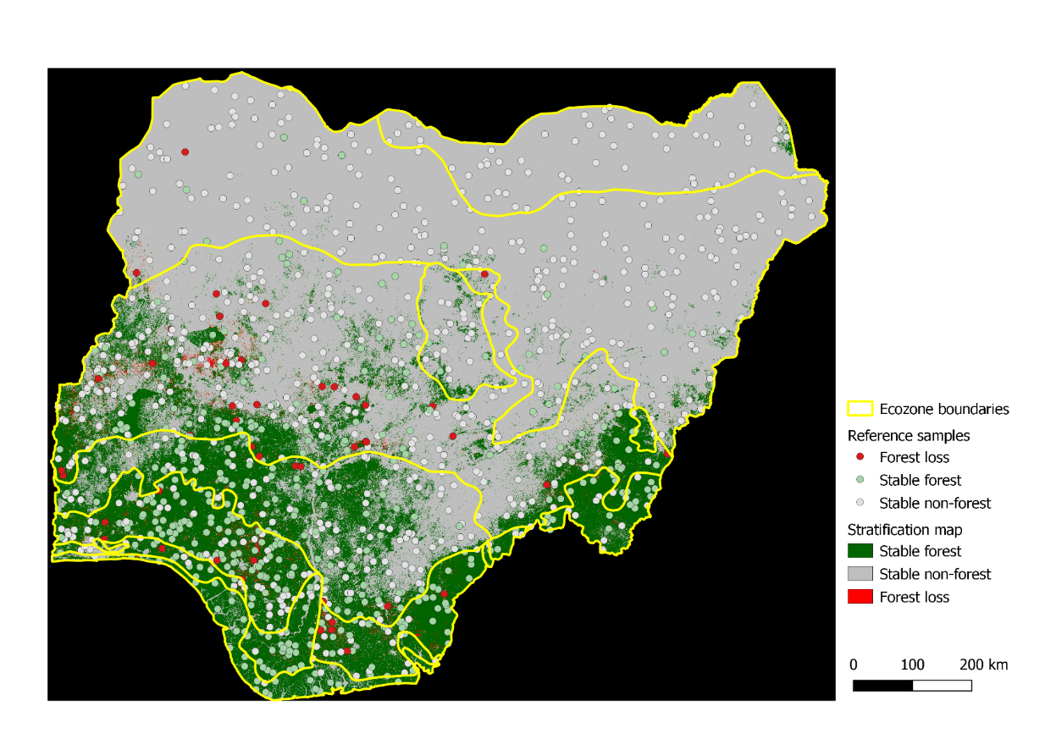

|  |
| --- |
| Figure 17. National Forest cover change map (2006-2016) from Hansen Map |

**5.1.5. Change Detection Analysis using SEPAL Collect Earth (Online)**

***Collection of Training Dataset***

A collect earth online project was created in SEPAL using CEO-SEPAL and the following forest cover change classes defined: stable forest, stable non-forest, forest loss, forest gain and other change. TheGlobal Forest Change 2000-2016 data (**Hansen et al., 2013**), was used to collect the training dataset. The data are available in Google Earth Engine data catalogue (<http://earthenginepartners.appspot.com/science-2013-global-forest>). After creating the project, sufficient data points were collected across the entire extent of the study area for each forest cover classes defined above. Stable classes are those that remained constant between the change dates. Forest Loss and Gain classes, are those that indicate changes between the Landsat mosaics. NDVI charts were used to assess the changes in vegetation. Once all the training data was collected it was downloaded and saved as a Fusion Table with a unique ID. The Table was subsequently used to run Change Detection.

***Change Detection Analysis***

Change detection was implemented using SEPAL’s Change Detection Tool. The two mosaics (2006 & 2016), and the fusion table containing the training dataset was used as inputs to the SEPAL Tool.

For the accuracy assessment and estimation of activity data, 1215 sample points were interpreted and stratified area estimates obtained using the Hansen map for stratification. The reference data were generated and interpreted first by the Remote Sensing/GIS Consultant with the aid of Collect Earth Online tools in SEPAL, and furthermore, by other 3 interpreters in compliance with recommendations by McRoberts et *al*. (2018). The error matrix and the stratified area estimates for the four classes (Stable Forest, Stable Non-forest, Forest Loss and Forest Gain) were calculated using the formulas as found in Olofsson et *al* (2014)*.* **Table 4** shows the error matrix for the interpreted samples while results of the accuracy assessment are presented in **Table 5** and has been based on the agreement amongst 3 interpreters. The overall weighted accuracy of is **81%** with a confidence interval for forest loss of **± 46%.** The results were also analysed by major ecological zones. The forest loss class is what constitutes deforestation.

|  |  |  |  |  |  |  |  |
| --- | --- | --- | --- | --- | --- | --- | --- |
| **2006-2016** | | Reference data | | | **Total samples in map class** | User's Accuracy | |
| Forest Loss | Stable Forest | Stable non-forest |
| Map data | Forest loss | 32 | 35 | 45 | 112 | 29% | |
| Stable Forest | 6 | 335 | 198 | 539 | 62% | |
| Stable non-Forest | 10 | 54 | 500 | 564 | 89% | |
| **Total reference samples per class** | | **48** | **424** | **743** | **1215** |  |  |
| **Producer's accuracy** | | 67% | 79% | 67% | **Overall accuracy** | | **71%** |
| **Weighted Producer Accuracy** | | 12% | 71% | 86% | **Weighted overall accuracy** | | **81%** |

## Table 4. Error matrix for the interpreted samples.

|  |  |  |  |  |  |  |
| --- | --- | --- | --- | --- | --- | --- |
|  | **Results stratified area estimates for:** | | | | |  |
| Variable | **Entire Nigeria** | **Sudan & Sahel Savanna** | **Guinea Savanna** | **Derived savanna** | **Lowland Rainforest** | **(Mangrove & Freshwater Swamp)** |
| **Stratified Area Estimate loss (ha/yr)** | **163,359** | **6,807** | **95,293** | **13,613** | **40,839** | **6,807** |
| **Standard error (ha/yr)** | **38,048** | **1585** | **22194** | **3170** | **9512** | **1585** |
| **95%Confidence Interval** | **74,573** | **3,107** | **43,501** | **6,214** | **18,643** | **3,107** |

## Table 5. Results of Accuracy Assessment and Stratified Area Estimation for Forest Classes for one interpreter.

## Figure 18. Estimated forest loss (deforestation) between 2006-2016 by ecological zones.

## Figure 19. Estimated Forest loss, Stable Forest and Stable Non Forest within ecological zones.

## Emission factor estimation

Emission factors are derived from forest inventory data. However, a review of historical inventories in Nigeria revealed a lot of limitations in their usage for forest biomass estimation, and carbon stocks determination; and hence, their use for estimating emission factors for REDD+ purposes. The inventories were originally designed for timber volume estimation for commercial tree species and not for all tree species, and estimations were limited to bole volume, and not for all carbon pools. Furthermore, results for forest inventory for Cross River State and used for the sub-national FREL was limited to CRS and did not capture all land use/land cover types in Nigeria. In order to circumvent this situation a national forest carbon inventory was designed and implemented to sample all main ecological zones and land use land cover types in Nigeria.

### Sampling design for Nigeria Forest Carbon Inventory

The sampling design consisted of nested sample plots that were randomly distributed across all ecological zones. A **stratified random sampling design** was used in order to capture spatial variability of land-use/land cover types and forest carbon stocks. The design was consistent with the one previously used for Cross River State. The stratification was based on main ecological zones as defined in FORMECU (1995): the mangrove forest and coastal vegetation, freshwater swamp forest, lowland rainforest, derived savanna, guinea savanna, montane forest, Sudan savanna, and Sahel savanna.). However, due to various risks levels associated with some States the sampling was further constained by eliminating high risks States. Details of the sampling approach are contained in the NFI report.

### Cluster Design and Characteristics

Each cluster covered an area of 205 m x 205 m, and consisted of three plots of 35 m x 35 m arranged in an L-shaped configuration (**Figure 20**) : the Elbow or central plot, the Northern and the Eastern plots distant at 100 m from the central plot, and arranged in an alternate manner. Each plot has three nested sub-plots of 25 m x 25 m, 7 m x 7 m and 2 m x 2 m.

All trees with diameters greater than 40 cm were measured based on the 35 m x 35 m plot; those between 10 cm and 40 cm were measured on the 25 m x 25 m nest and those between 5 cm and 10 cm were measured in the 7 m x 7 m nest. Regeneration was tallied in the 2 m x 2m nest. Standing dead trees were measured in the corresponding nests using the same diameter cut-off points as for life trees. Fallen dead trees with diameter greater than 10 cm were measured in the entire plot; while those below 10 cm were measured in the 7 m x 7 m sub-plot.

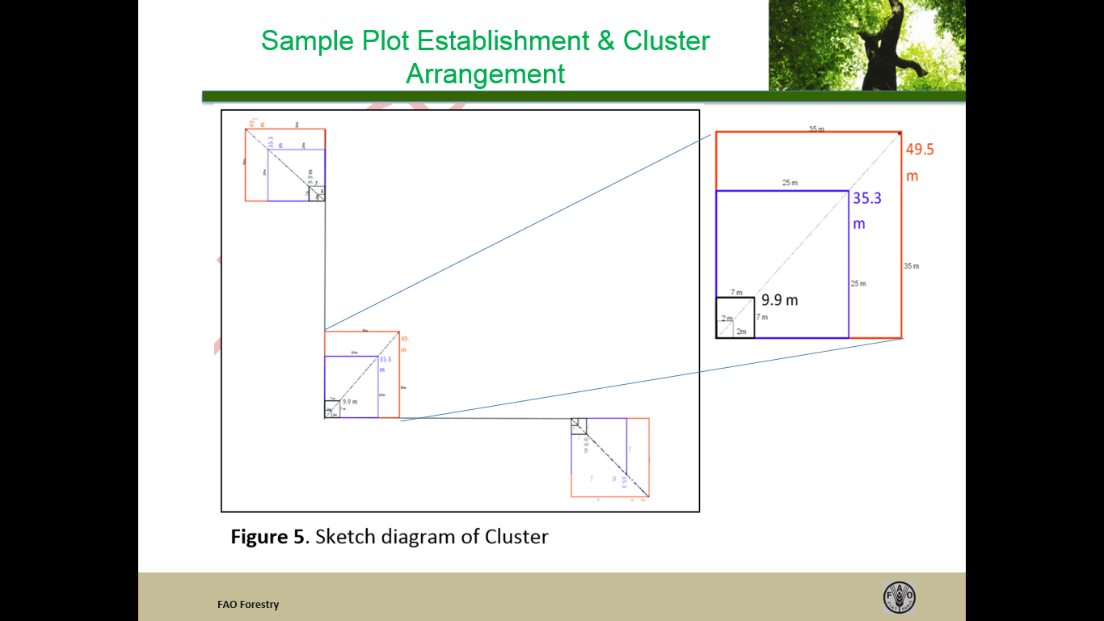

## Figure 20. Cluster design used for the inventory

### Sample Plot Design: Mangroves & FWS

An initial attempt to sample mangroves and fresh water swamps using the above design failed due to the conditions of these ecosystems. Hence, we resorted to use a design similar to the one used for Cross River State Inventory and described in Ajonia (2008). The design uses three- 10m x 20 m rectangular plots laid along a transect at intervals of 10 m; with 5 m x 5 m sub-plots nested within them, and in an alternate manner shown below (**Figure 21**).

All trees with diameter > 10 cm were measured in the entire plot (for trees with stilt/roots, measure diameter at 0.3 m (30 cm) above stilt. On the 5 m x 5 m sub-plot, all trees with diameter < 10 cm and height > 1.3 m were measured in the 5 m x 5 m subplot. Stilts were sampled in a 1 m x 1 m randomly located quadrat; soil samples were collected for soil organic carbon estimation.

* 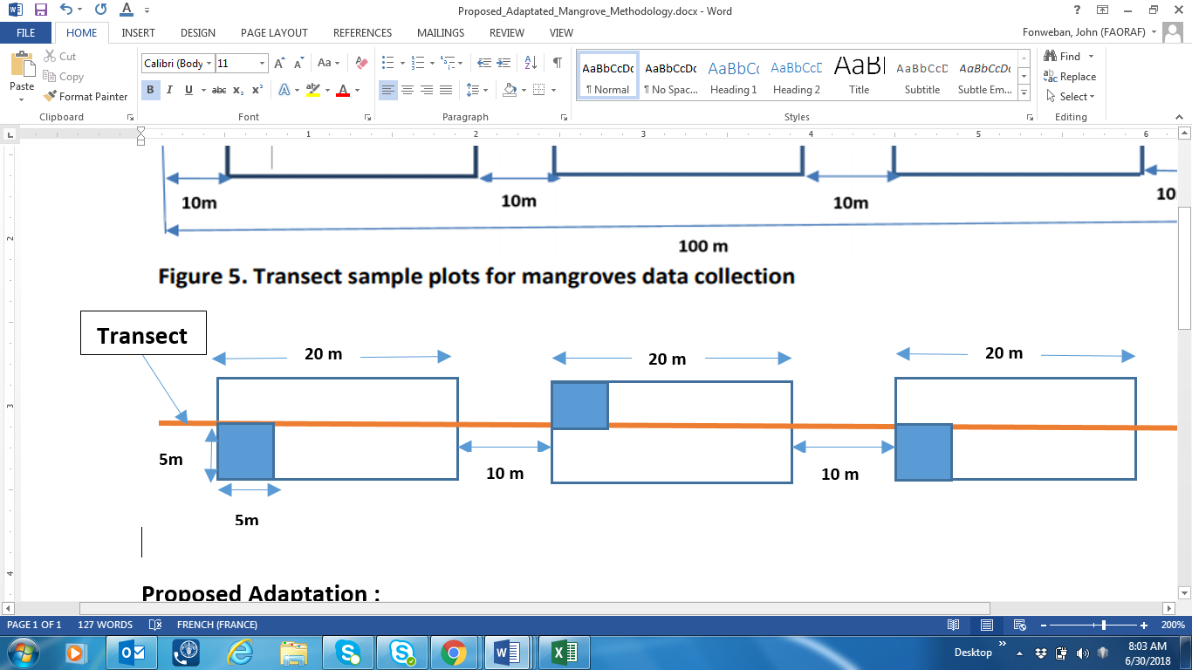

## Figure 21. Sketch diagram of sample Transect sampling design for Mangroves and Fresh Water Swamp Forest.

**Figure 22** shows the spatial locations of the clusters sampled in various ecological zones, while **Table 6** shows the number clusters by State and ecological zone[3].

|  |  |  |  |  |  |  |  |  |  |
| --- | --- | --- | --- | --- | --- | --- | --- | --- | --- |
| **State** | **Mangrove Forest** | **Freshwater Swamp Forest** | **Lowland Rainforest** | **Derived Savanna** | **Guinea Savanna** | **Sudan Savanna** | **Sahel Savanna** | **Montane Forest** | **TOTAL** |
| **Jigawa** | **0** | **0** | **0** | **0** | **0** | **0** | **3** | **0** | **3** |
| **Katsina** | **0** | **0** | **0** | **0** | **0** | **1** | **2** | **0** | **3** |
| **Kebbi** | **0** | **0** | **0** | **0** | **0** | **3** | **0** | **0** | **3** |
| **Nasarawa** | **0** | **0** | **0** | **0** | **10** | **0** | **0** | **0** | **10** |
| **Ogun** | **3** | **7** | **13** | **4** | **0** | **0** | **0** | **0** | **27** |
| **Ondo** | **9** | **3** | **24** | **4** | **0** | **0** | **0** | **0** | **40** |
| **Oyo** | **0** | **0** | **4** | **5** | **3** | **0** | **0** | **0** | **12** |
| **Taraba** | **0** | **0** | **0** | **0** | **0** | **0** | **0** | **18** | **18** |
| **TOTAL** | **12** | **10** | **41** | **13** | **13** | **4** | **5** | **18** | **116** |

## Table 6. Number of Clusters enumerated in different ecological zones in Nigeria.

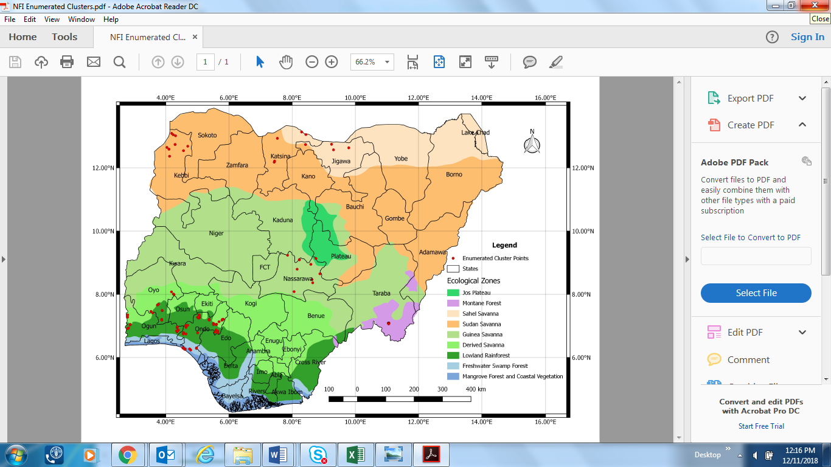

## Figure 22. Spatial Distribution of Sample Clusters in different Ecological Zones.

### Data Collection: Above Ground Biomass

***Stem Diameter Measurements.***

All trees in the plot above 5 cm diameter at breast height (dbh) were identified as much as possible to species level and measured at 1.3 m from the ground, with d-tape. However, for trees with anomalies and/or multiple stems, measurements were made according to the instructions in the box below:

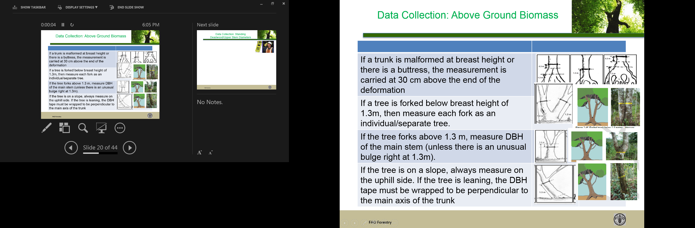

***Tree Height Measurements***

The TruPulse 200B Laser Rangefinder was used to measure tree heights (bole and total heights) on a sample of trees whose boles were clearly visible from base to top. Specific crew members were assigned the task of height measurements based on their good mastery of the laser equipment following training received prior to the field work. In addition to height measurements, three diameter measurements were measured with the Criterion RD1000 Laser Dendrometer: diameter at tree base (Dbase), diameter at mid-stem (Dm) and diameter below large branch (Dtop). These measurements, plus the bole height were used compute tree bole volumes using Newton’s Log Formula.

***Standing Deadwood and Stumps***

Standing dead trees were measured for diameters and heights concurrently with live trees, and in the corresponding nests, according to tree sizes. Three diameter measurements were taken using the Criterion RD1000 laser dendrometer: diameter at the base of the dead tree (**D**base); diameter at breast height (dbh), and diameter at top of dead tree (**D**top). Deadwood bole height (H) was measured with the TruPulse 200B Ranger finder.

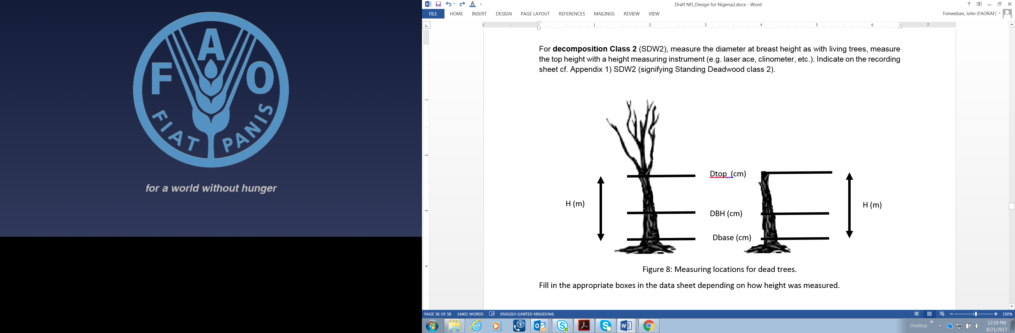

Two deadwood status were distinguished:

**Category 1**, includedtrees with branches and twigs that resembled live trees (except for the absence of leaves);

**Category 2 -** Tree without twigs and branches, and already showing signs of decomposition or decay.

The decay categories were determined using a “*Matchete Test*” which assigns deadwood (standing or lying) into one of three density categories: sound (S), intermediate (I) or rotten (R), by striking the wood with a matchete. If on striking the deadwood the matchete:

1. bounces back, then the piece is classified as sound (S)
2. partly sinks into the wood then it is classified as intermediate (I)
3. sinks into the wood and the wood crumbles then the wood is categorized as rotten (R).

Stumps were measured for diameter and height in corresponding subplots based on their sizes.

***Lying (down) Deadwood or Coarse Woody Debris***

Only lying deadwood (and dead branches) that had a minimum diameter of 10 cm diameter and at least 1 m long were measured. Where a dead lying tree contained the stump part with some roots; the stump data is recorded in the stumps section on the field form. The “*matchete test*” was used to determine the decay category as (described above). Deadwood with diameter>10 cm and greater than 1 m long were measured in the entire plot; while fine woody debris (FWD) (diameter between 2 cm to 10 cm, and deadwood with diameter > 10 cm but with length < 1m) were measured only within the 7m x 7 m nest. All sections of the deadwood falling outside the plot boundaries were excluded (see illustration below).

Measurements taken included a diameter at tree base (**D**base), diameter at top (**D**top) and deadwood length (L). These measurements were used to compute deadwood volumes using Smalian formula.

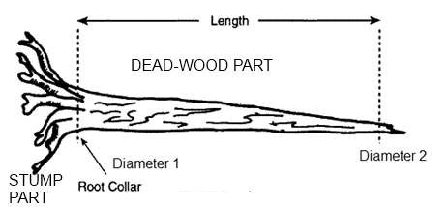 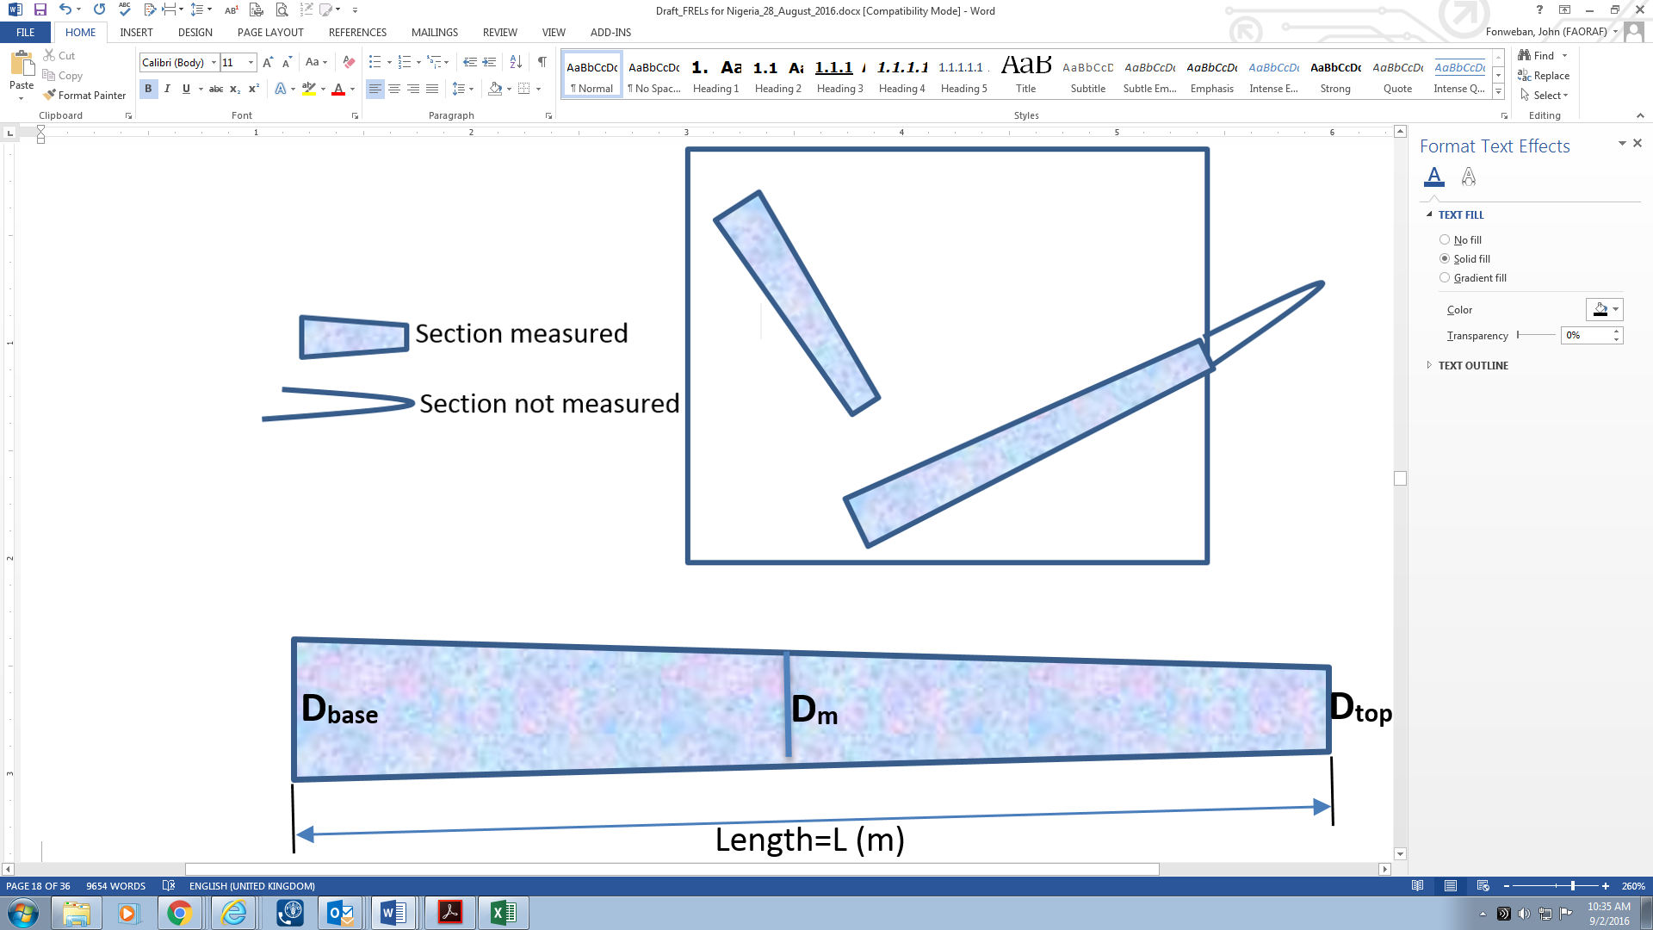

***Extraction of Core Samples for Wood Density Determination.***

Wood core samples were extracted from tree species using an increment borer for wood density determination. Trees were cored from bark towards the pith, where possible, at breast height with a 5.15 mm diameter increment borer. The bark was removed from the cores, and the samples weighed (fresh weight) on an electronic balance, labelled and placed in increment core holders. The fresh volume of each sample was calculated using the diameter of the borer (d) and the length of the core (L) as follows:

$$V=[{d^{2}L]/4}^{}$$

where V is volume, d is mean diameter, L is length, π=3.14.

The samples were oven-dried to constant weight, and weighed with an electronic balance. The dry weight divided by the fresh volume for each sample gave the wood density (FAO 1997, Chave et al. 2005, Navarro et al. 2013). Wood density of a species was computed as the arithmetic average value of all samples of that species.

### Data Analysis

***Above Ground Biomass***

The conversion of field data collected to forest biomass and carbon stocks requires the use of biomass allometric equations. The following steps were used to estimate above ground biomass for each land use/land cover type:

1. For each tree in the plot/nest the above ground dry biomass was estimates using the selected allometric equation.

2. Its biomass was then multiplied by the correct scaling factor based on the sub-plot size in which the tree was measured to get the biomass in Kg/ha.

3. The biomass in kilograms was converted to biomass in tons per hectare.

4. Biomass per hectare of all trees in each plot were summed to get an estimate of total biomass per hectare.

In the absence of country-specific allometric equations, a pan-tropical allometric equation by Chave *et al* (2014) below was used to estimate above ground biomass from field measurements.

$${AGB}_{est}={(0.0673ρD^{2}H)}^{0.976}$$

(σ =0.357, AIC=3130, df=4002).

where:

*AGBest* = above ground biomass (kg)

*ρ* =species wood density (g/cm3)

*D*=diameter at breast height (cm)

*H*=tree height (m)

The equation also requires an estimate of tree height, and wood density. Given that tree heights were not measured on all trees during the inventory, we developed a height-diameter equation using the height-diameter measurements made during the inventory. The equation is as follows:

$$H_{est}={1.3+30.441065[1-exp⁡(-0.040144*dbh}^{0.8239})]$$

Wood density estimates were obtained from core samples collected during inventory (as described above), and additional data from a number studies undertaken in Nigeria (Chenge, 2017; Aghimien E.V; and Akindele (unpublished)), and from global database (Zanne *et al*. 2009), for species without local wood density values.

Above ground biomass (including stilt roots) for trees sampled in mangroves was estimated using the following equations for all mangrove species developed by Komiyama *et a*l (2005), and which has been widely used (cf. Komiyama et *al*. 2008; Kauffman and Donato, 2012; Allemayehu et *al*. 2014.):

: R2=0.98, n=104

***Standing Dead Wood***

Standing deadwood measurements included diameter at tree base (Dbase), diameter at top of tree bole (Dtop), bole height (H), and determination of decomposition status of the deadwood. The volume of each deadwood was then calculated assuming the tree is a frustum of truncated cone. Depending on whether or not the diameter at bole top is available, the following formulae was used to estimate standing deadwood volume.

$$Volume=\left\{\begin{aligned}\left(\frac{π*H}{12}\right)\left(D_{base}^{2}+(D_{base}.D_{top}\right)+D_{top}^{2}), if tree is assumed frustum of truncated cone \\ \left(\frac{π*H}{3}\right).{\left(\frac{D_{base}^{2}}{2}\right)}^{2} if tree is assumed frustum of a cone (D_{top}=0)\end{aligned}\right.$$

Deadwood volumes were converted to dry biomass using deadwood density values based on deadwood density values obtained during the inventory and also from a study by Akindele (*unpublished*). The values used are 0.46 for sound deadwood standing, and 0.36 for Intermediate standing deadwood.

***Lying Dead Wood***

Lying (down) deadwood volume is ccomputed using Smalian’s formula, assuming frustum of a paraboloid:

$$Volume=\frac{π.L}{8}\left(D_{base}^{2}+D_{top}^{2}\right)$$

Biomass of lying deadwood was then estimated as Volume x Density.

The value for sound dead wood density used were based on a study by Akindele (*unpublished*), which provided the following density estimates: 0.31 for sound lying deadwood, 0.26 for intermediate lying deadwood and 0.21 for rotten deadwood.

***Stump biomass***

The volume of the stump was estimated using the formula below:

$$Volume=\frac{π.Hstump*D_{stump}^{2}}{4}$$

Biomass of stump was then estimated as Volume x Density.

***Below Ground Biomass***

The estimation of below ground biomass (BGB) is difficult and expensive to undertake in most tropical high forest, and few country-specific allometric equations exist for BGB. Most projects or studies therefore resort to the use of a proxy root-to-shoot (R/S) ratios (Kauffman and Donato, 2012). In the present study we used a ratio equation for moist tropical forests developed by Mokany *et al*. (2006; also reported in the IPCC 2006 AFOLU), which predicts below ground biomass (BGB) based on above ground biomass (AGB) as follows: $BGB=\left\{\begin{aligned}0.235*AGB if AGB>62.5t C/ha \\ 0.205*AGB if AGB≤62.5 t C/ha\end{aligned}\right.$

Belowground biomass for **mangroves** (excluding stilt roots) was estimated using the following equation by Komiyama *et al* (2005) :

R2=0.95; n=26.

***Estimation of Carbon content***

The carbon content of biomass was estimated by applying a conversion factor of **0.47** to total biomass, 0.47 is default carbon fraction or conversion factor applicable for tropical and sub-tropical species (range 0.44 - 0.49) (see Table 4.3 Chap. 4. IPCC 2006), while the carbon dioxide equivalent (CO2e) was computed by multiplying the carbon content by **3.67** (44/12) (IPCC 2003, 2006). **Table 7** present summary results for the total live carbon stock estimates (for above and below ground biomass) and total deadwood carbon stocks (sum total for standing deadwood, lying deadwood and stumps) for different for major ecological zones. Detailed tables for intermediate calculations have been left out, and can be found in the forest carbon inventory report. The estimates retained are those to serve as emission factors for FREL calculations.

|  |  |  |  |  |  |  |  |
| --- | --- | --- | --- | --- | --- | --- | --- |
| **Ecological Zone** | **Total Live Carbon stock**  (tCO2/ha) | **[95% CI]** | **Total Deadwood Carbon stock**  **(tCO2/ha)** | **[95% CI]** | **Total Live & Dead Carbon stock**  **(tCO2e/ha)** | **95% Confidence Interval (CI)** | |
| **Mean** ± **StdError** | **CI%** | **Mean** ± **StdError** | **CI%** | **Mean** ± **StdError** | **CI (tCO2e/ha)** | **CI%** |
| **Derived Savanna** | 253.88±99.84 | 77.1% | 19.71±5.31 | 52.8% | 273.59±99.98 | 195.95 | 71.6% |
| **Sahel, Sudan & Jos Plateau** | 20.18±4.16 | 40.4% | 3.77±?? | ---- | 23.95±4.16 | 8.15 | 34.0% |
| **Guinea Savanna** | 98.76±18.72 | 37.2% | 3.93±0.65 | 32.3% | 102.69±18.73 | 36.71 | 35.8% |
| **Lowland Rainforest & Montane** | 368.59±31.65 | 16.8% | 30.79±3.87 | 24.7% | 399.39±31.88 | 62.49 | 15.6% |
| **Mangrove & FWS** | 321.02**±**66.57 | 40.6% | 15.76±2.83 | 35.1% | 354.53±70.81 | 138.78 | 39.1% |

## Table 7. Total live and Dead Biomass and Carbon Stocks for different ecological zones in Nigeria.

# Transparent, complete, consistent and accurate information

## Transparent information

During the development of the FREL document, all processes followed and methodologies used for the estimation of activity data and emission factors were documented in a transparent manner. Some information is provided in the appendices to this document. All maps used for estimating activity data have been referenced, and both metadata and spatial datasets are available in a spatial database. Also for the estimation of emission factors, based on forest inventory data, all calculations have been done in a transparent manner. The spreadsheets are available, and some detail results have been included in the Appendix to this document.

## Complete information

Annex I in Decision 12/CP.17 indicates that complete information means information provided that allows for the reconstruction of forest reference emission levels and/or forest reference levels. All information used in the context of the construction of the present FREL has been developed by Nigeria, and allows for the reconstruction of the FREL and is publicly available. Nigeria also ascertains that all information used for the construction of Nigeria’s FREL will be uploaded to the website and is available for download.

## Consistent information

Consistency with the national greenhouse gas inventory paragraph 8 in Decision 12/CP.17 establishes that FRELs and/or FRLs shall maintain consistency with anthropogenic forest related greenhouse gas emissions by sources and removals by sinks as contained in the country’s national greenhouse gas inventory. Compared to the second National GHG Inventory (NGHGI) submitted by Nigeria in its Second National Communication, there was no clear forest definition used. The second NGHGI did not include a forest definition and was using data available at the time which concerning forests is likely to have been focussed on tropical high forest only.

## Accurate information

### Accuracy of the estimated activity data

Same process was repeated for Hansen maps for the purpose of comparison. The results of the comparative analysis informed the decision to opt for Hansen datasets for the creation of new change layer through direct change assessment using FAO-SEPAL platform at FAO Rome. Reference data were generated for the accuracy assessment using land use/land cover maps in **section 5.1.3** for Nigeria and Hansen maps stratifications.

### Uncertainty of the estimated emission factor

The estimation of emission factors is associated to many sources of uncertainty, including the use of default values, sampling errors and bias from field measurements, etc. All biomass estimates (**Tables 7)** from the inventory were reported with 95% uncertainty values associated with them. Also, **Table 8** gives 95% uncertainty estimates for above and below biomass carbon pools for different land use types. The uncertainties are all below 100%; with those for deadwood.

|  |  |  |  |
| --- | --- | --- | --- |
|  | **Uncertainty Estimates (% of mean values) for:** | | |
| **Ecological Zone** | **Total (ABG & BGB) Live Carbon Stock (tCO2/ha)** | **Total Deadwood Carbon Stocks (tCO2/ha)** | **Total Live and Dead wood Carbon Stocks (tCO2/ha)** |
| **Derived Savanna** | ±77.1% | ±52.8**%** | ±71.6% |
| **Guinea Savanna** | ±37.2% | ±32.3**%** | ±35.8% |
| **Lowland Rainforest & Montane** | ±16.8% | ±27.5**%** | ±15.6% |
| **Mangrove Forest & FWS** | ±40.6% | ±35.1**%** | ±39.1% |
| **Sahel, Sudan & Jos Plateau** | ±40.4% | - | ±34.0% |

## Table 8. Uncertainty estimates (95% confidence intervals) for total live and deadwood carbon stocks by ecological zones

# FREL/FRL Construction

## Reference Period

The initial reference period will include data from 2006 to 2016 and annual historical deforestation rates have been considered for this period.

## Average Method

Emission Factors and Activity Data have been estimated by ecological zones and are shown in Tables 19 below. The annual emissions for the period 2006-2016 was estimated as the product of the average annual deforestation (Activity Data: AD) and the estimated CO2 e per hectare (Emission Factor) by ecological zone, then summed up to provide the average annual emissions (**Table 9**). Average values for emissions and their confidence intervals were also computed in order to determine the upper and lower limits of the estimates.

|  |  |  |  |  |  |  |  |  |
| --- | --- | --- | --- | --- | --- | --- | --- | --- |
|  | **Activity Data [AD]** | | **Emission Factors[EF]** | | **Annual Emissions [2006-2016: tCO2e]** | | | |
| **Agregated Ecozone** | **Forest loss [ha/yr]** | **StdError**  **(ha/yr)** | **EF (tCO2e/ha)** | **StdError**  **(tCO2e/ha)** | **Emissions=EF*AD** | | **CI(EF*AD)** | **CI%** |
| **Derived Savanna** | **13613.25** | **3170.63** | **273.59** | **99.97** | **3724449.1** | **1613919.4** | | **43.33%** |
| **Guinea savanna** | **95292.78** | **22194.43** | **102.69** | **18.73** | **9785615.6** | **2894822.7** | | **29.58%** |
| **Lowland Rainforest & Montane** | **40839.76** | **9511.90** | **399.39** | **31.88** | **16310991.7** | **4015868.9** | | **24.62%** |
| **Mangrove swamp** | **6806.63** | **1585.32** | **354.53** | **70.81** | **2413154.5** | **740383.9** | | **30.68%** |
| **Sudan sahel** | **6806.63** | **1585.32** | **23.95** | **4.16** | **163018.8** | **47356.7** | | **29.05%** |
| **Annual Emissions (tCO2e/yr)** |  |  |  |  | **32,397,229.7** |  | |  |

## Table 9. Summary computations for Emissions

# Areas for future improvements

FREL/FRL development is a stepwise process and Parties are encouraged to improve and update it as soon as more accurate information becomes readily available. The present FREL constitutes an up-scaled version of the Sub-National FREL developed for Cross River State and submitted for technical assessment in January 2018. A number of improvements highlighted in the sub-national FRELs, including data collection for deadwood carbon pool, and tree height measurements have been captured in the national FRELs. Furthermore, core samples were extracted from live trees for wood density determination, as well as deadwood density determination; and a litter sampling was done in a small sample of plots in some ecological zones. The activity data has also been stratified by main ecological zones.

Never-the-less, there are still several avenues for further improvement to the present national FREL document. Some important areas for improvement are as follows:

1. **On the Scope of activities:** Deforestation is the main emission activity addressed in the present FREL. Further improvement will require the inclusion of **forest degradation** which also leads to a lot of emissions through timber harvesting, fuelwood harvesting, and forest fires. The estimation of emissions from forest degradation is more challenging than for deforestation. **Afforestation (enhancement)** could be one of the areas of improvement given the long history of plantation silviculture in Nigeria; during which parts of forest reserves were replanted. Field inventory revealed this, especially in the lowland rainforest.
2. As regards **emission factors (EF)** determination, the inventory design attempted to sample all major ecological zones from coastal mangroves and FWS to Sudan and Sahel savanna ecosystems; and EFs have been computed per major ecological zones. However, from the confidence intervals obtained, the level of uncertainty is still high for some ecological zones, and it will be important (subject to availability of funds), that additional and intensive inventories be undertaken to improve on the precision and accuracy of the estimates. The estimates used in the present FREL can serve in the optimization of a future inventory sampling design.
3. Regarding the **activity data** (**AD**), work was undertaken to produce land use/land cover maps, change detection analysis and accuracy assessment. However, considering the large size of the country, and problems with “pixel-based” change analysis, the use of Hansen GFC data was recommended for AD estimation. Further improvements could be made on the land use land cover maps.

# References

**Ajonia G.N. 2008**. Inventory and Modelling Mangrove Forest Stand Dynamics following different levels of wood exploitation pressures in the Douala-Edea Atlantic Coast of Cameroon. PhD Thesis. Albert-Ludwig-Univers sitat Freiburg im Breisgau, Germany.

**Alemayehu, F., Richard O., Mwangi J. K., and Wasonga O. 2014**. Assessment of Mangrove Covers Change and Biomass in Mida Creek, Kenya. *Open Journal of Forestry*, 2014, 4, 398-413

**Akpa S.I.C., Odeh I.O.A., Bishop T.F.A., Hartemink A.E., Amapu I.Y., 2016**. Total soil organic carbon and carbon sequestration potential in Nigeria*. Geoderma 271 (2016) 202–215*

**Chao K**-J, Phillips O.L., and Baker T.R. 2008. Wood density and stocks of coarse woody debris in a northwestern Amazonian landscape.

**Chave, J., Andalo, C., Brown, S., Cairns, M.A., Chambers, J.Q., Eamus, D., Fölster, H., Fromard, F., Higuchi, N., Kira, T. et al. 2005**. Tree allometry and improved estimation of carbon stocks and balance in tropical forests. Oecologia 145 : 87-99.

**Chave, J., Réjou-Méchain, M., Búrquez, A., et al., 2014**. Improved allometric models to estimate the aboveground biomass of tropical trees. Glob. Change Biol. 20, 3177–3190.

**Chenge I**.B. 2017. Estimation of tree aboveground biomass and carbon stocks in Omo Biosphere Reserve, Nigeria. PhD Thesis, Univesity of Ibadan, Nigeria.

**FAO, 1996.** Forest Resource Assessment 1990: Survey of Tropical Forest Cover and Study of Change Processes. FAO Forestry Paper 130. 152 pages

**Feldpausch, T.R., Lloyd, J., Lewis, S.L., Brienen, R.J.W. et al. 2012.** Tree height integrated into pantropical forest biomass estimates. Biogeosciences 9, 3381–3403.

**FORMECU, 1998.** The Assessment of Vegetation and Landuse Changes in Nigeria. Geomatics International Inc. for Federal Department of Forestry, Abuja, Nigeria

**Hansen M. C., Potapov P. V., et al., Moore R., 2013**.High-Resolution Global Maps of 21st-Century

Forest *Cover Change.* Department of Geographical Sciences, University of Maryland, College Park, MD 20742, USA. *Google, Mountain View, CA, USA.*

**Harmon, M.E. and J. Sexton.(1996)** Guidelines for measurements of woody detritus in forest ecosystems.US LTER Publication No. 20.US LTER Network Office, University of Washington, Seattle, WA, USA.

**IPCC 2006,** 2006 IPCC Guidelines for National Greenhouse Gas Inventories, Prepared by the National Greenhouse Gas Inventories Programme, Eggleston H.S., Buendia L., Miwa K., Ngara T. and Tanabe K. (eds). Published: IGES, Japan.

**Kauffman J.B. and Donato D.C. 2012.** Protocols for the measurement, monitoring and reporting of structure, biomass and carbon stocks in mangrove forests. Working Paper 86, CIFOR, Bogor, Indonesia. 50 pages.

**Keay, R. W .J. 1949**. An outline of Nigerian vegetation; Nigerian Forestry Department, Government Printer, Lagos, 52p.

**Komiyama, A., Poungparn, S., Kato, S. 2005** Common allometric equations for estimating the tree weight of mangroves. Journal of Tropical Ecology 21: 471-477.

**Komiyama, A., Ong, J.E., Poungparn, S. 2008** Allometry, biomass, and productivity of mangrove forests: A review. Aquatic Botany 89: 128-137.

**McRoberts et al. (2018). The effects of imperfect reference data on remote sensing-assisted estimators of land cover class proportions. ISPRS Journal of Photogrammetry and Remote Sensing.142:292-300.**

**Mokany, K., Raison, R.J., Prokushkin, A.S., 2006**. Critical analysis of root: shoot ratios in terrestrial biomes. Global Change Biol. 12, 84–96.

**Olofsson P., Giles M. Foody, et al**., **2014.** Good practices for estimating area and assessing accuracy of land change

**Pearson T., Walker S., Brown S. (2005)** Sourcebook for Land Use and Land-Use change and Forestry Projects (Winrock International)

**Tewkesbury, A.P., Comber, A.J., Tate, N.J., Lamb, A. & Fisher, P.F. 2015.** A critical synthesis of remotely sensed optical image change detection techniques. *Remote Sensing and Environment*, 160 (2015): 1–14.

**Zanne, A.E., Lopez-Gonzalez, G., Coomes, D.A., Ilic, J., Jansen, S., Lewis, S.L., Miller, R. B., Swenson, N.G., Wiemann, M.C., Chave, J., 2009**. Towards a worldwide wood economics spectrum.

# Appendices (separate document)

1. Nigeria, F. G. (2017). Federal Republic of Nigeria. Retrieved June 15, 2017, from http://www.nigeria.gov.ng/
2. Detail land use/land cover maps for the four epochs are presented in a separate report. For the FREL development only the 2006 & 2016 maps are presented in this report.
3. The distribution presented here refers to the actual clusters measured in the field, which is a sub-set of the sampling frame that consisted of 240 clusters.